

Viewing Summary Care Records (SCRs) for non GMS patients within EMIS Web
Within the EMIS Web system it is possible for GP practice staff to view SCRs for non-GMS registered patients when the patient gives their permission to do so. This increases the quality of information available to the clinician at the point of treatment and may reduce the need to contact the patient’s registered practice by fax or telephone. Where the patient cannot give their permission the clinician treating the patient can still access the SCR where it is deemed in the best interests of the patient. In this instance a privacy alert will be generated.

GP practice staff are able to benefit from viewing SCRs for temporary residents (Non-GMS), with permission from the patient. However, they do not need to obtain the patients permission for their own GMS patients due to the fact that they are fully registered (GMS) at that practice.

The functionality can also be beneficial for treating new patients to a practice that are not yet fully registered. Often these patients will arrive with a request to register and need an immediate prescription or treatment. In these cases, the patient’s current SCR can be accessed prior to completion of registration and before detailed records arrive from their former practice or via GP2GP.

In line with the usual governance associated with the accessing of patient records, the Caldicott Guardian within each organisation has a responsibility for protecting confidentiality when it comes to SCR viewing for organisations viewing SCRs for non-GMS patients, it is mandatory for the organisation to have at least one nominated Privacy Officer in place. This may be the same person who currently manages alerts that EMIS Web already generates, however the alerts generated when viewing SCRs are managed and closed via the NHS (Spine) portal.

The Privacy Officer will need to manage any alerts that are generated via the Alert Viewer system on the NHS Spine Portal. It is worth noting that the Alert Viewer will not allow alerts to be closed by the same individual who created them, therefore practices may wish the Privacy Officer to be an appropriate member of staff who will not normally access SCRs. For further information regarding the setup of a Privacy Officer please see pages 6-7 of this document.

Viewing is available for patients with one of the following registration types:

a) Temporary Residents b) Walk In Patient
c) Immediate Necessary d) Other

This viewing pack contains information for you to be able to:
• Enable the functionality within EMIS Web
• Request or set up the necessary Role Based Access (RBAC) code
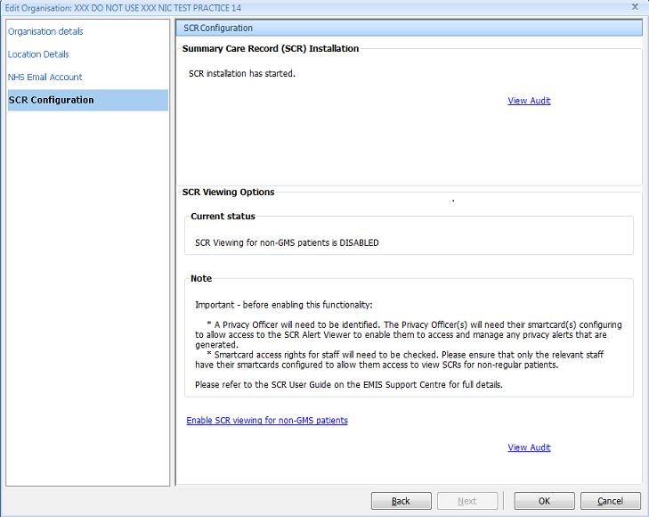
• View the Summary Care Record and record Permission to View (PTV) • Manage alerts using the Alert Viewer on the NHS Portal

Enabling the functionality

Depending on the EMIS product you are using the method of enablement is different. If you are using a GP EMIS Web product please use Method 1 below. If you are using a EMIS Community/Other Non-GP product please follow Method 2 on page three.

Method 1 - For GP Practices ONLY

1. Click at the top left and point to Configuration, click Organisation Configuration, and then click the Organisations tab at the bottom of the navigation pane.

2. In the navigation pane, select your organisation.

3. On the Organisation Configuration ribbon, click Edit. The Edit Organisation screen is displayed.

4. In the left-hand pane, click SCR Configuration.

The SCR Configuration pane is displayed on the right-hand side of the screen.
In the SCR Viewing Options section, click Enable SCR viewing for non-GMS patients.
Note: If you click this option, its text changes to Disable SCR viewing for non-GMS patients.
5. Click OK.

Method 2 - For EMIS Community/Non-GP products ONLY
- Contact EMIS Customer Fulfilment on 0113 380 3824 or DeploymentServices@e-mis.com

- Your details will be passed to the Deployment Team to enable SCR functionality for your organisation.

- Spine Endpoint changes which need to be configured by the Deployment Team before enablement is completed.

- Once the Spine Endpoint changes have been complete the Deployment Team will make you aware you that the SCR functionality is available.

Smartcard Roles (RBAC)

Staff involved in viewing SCRs or managing alerts may need additional roles or activities added to their smartcards, so it is recommended you discuss your requirements with your local Registration Authority as soon as possible.

To view Summary Care Records and Emergency Access (Clinical Staff):
- B0370 - (View Summary Health Records) – Gives access to the SCR Viewer.
- B0168 (View when permission could not be requested) - Emergency access to view the SCR.
- B0082 (Legal Override of Consent) - Legal access to view the SCR (Optional)

To View and Manage Alerts (Privacy Officer):
Privacy Officer
- S8002 : G8003 : R0001
- Admin and Clerical : Admin and Clerical : Privacy Officer
Where possible, Privacy Officers should not have any access to view SCRs

Viewing the Summary Care Record

Before accessing the Summary Care Record the patient must be registered in EMIS Web as one of the relevant categories (see page 1) and must be traced and synchronised with the personal demographics service (PDS) so that an NHS number is available. This is confirmed when the PDS button on the patient banner is blue:

- Select your patient

- From the Care Record Module select Summary

- Click on the double arrow on the pane displayed on the left hand side of the screen
- Select Summary Care Record
- The Permission to View screen is displayed:

6. In the top section, select the required option from the following:

- Yes (View Record): if you select this option, you can type additional supporting information about why you are viewing the record and then view the patient’s SCR.

- No (Access Refused): if you select this option, you can type additional supporting information if necessary, but you cannot access the patient’s SCR.

- Emergency Access: if you select this option, you must select the reason for access and type additional supporting information. You can then access the SCR Viewer.

Note: This option is only available if you have RBAC activity B0168 View when permission could not be requested in your role profile.

- Access for Legal Reasons: if you select this option, you must select the reason for access. This option is used in rare cases when the SCR is being viewed outside of a clinical consultation such as audit or investigation. If you select this option you can type additional supporting information.

Note: This option is only available if you have RBAC activity B0082 Legal Override of Consent in your role profile.

7. All additional supporting information recorded will be visible to the Privacy Officer (PO).

8. Click OK.

Unless the patient has refused permission, the SCR is displayed and can be printed if required. Click on Close to return to the Summary screen.

If a patient has opted out from Summary Care Records, there will be no clinical information to view.

Summary Care Record Content

The Summary Care Record (SCR) consists of the following core data items from the patient GP record:
- Allergies and adverse reactions.
- Acute medication – prescribed in last 12 months (unless otherwise specified).
- Repeat medication – All current repeat medications.
- Discontinued repeat medication – repeat medication which has been stopped in the last 6 months.

In addition, further useful additional may be included with patient consent.
Changes made to data items in the GP record will be updated in the SCR automatically. Below is an example screen shot of a Summary Care Record from EMIS Web:

When viewing Summary Care Records it is important to note:
- SCRs do not remove the requirement for verbal medical history taking where possible.
- Always check the date stamp of the SCR, this may determine whether the SCR is current and up to date.
- The SCR may display either the Last Issue Date or First Added Date for
medications.
- Some SCRs may not include Discontinued Repeat Medication.
- Text may be displayed to show that the patient is newly registered at
their own practice, so the SCR may not yet be fully up to date.
- Text may indicate that some items may have been deliberately withheld.
- Text may also, indicate that the SCR is no longer being updated by the
practice.
- Completeness and Data Quality – Additional Information added to the SCR
include data items defined in the SCR inclusion set or specific to the supplier’s
GP system implementation of SCR. The quality factors including the
underlying clinical record, data quality and confidentiality and completeness
of the SCR is dependent on a number of as a result, SCR viewers should be
aware that the SCR potentially may not be complete. The SCR is a valuable
source of information but clinicians should aim to validate this information
through discussion with the patient, family, carers or GP practice. Always
check the date stamp of the SCR, this may determine whether the SCR is
current and up to date.

Further information can be found at the EMIS resource centre:
https://emissupportcentre.emis.com/app/login?redirect=/help/care-record/summary-2/summary/viewing-scr-information/

Privacy Officer Setup & Activities

The Privacy Officer RBAC codes will automatically give access to the Alert Viewer on the NHS Spine. This does not need to be requested separately.

It is recommended that the Privacy Officer regularly accesses the Alert Viewer in order to manage Alerts that have been generated. This can be through checking on a regular diary date or alternatively setting up email alerts via the Spine Portal.

To set up email alerts please see the Alert Preference User Guide on the following link: https://digital.nhs.uk/summary-care-records/information-governance

Once set up, any alerts that are generated will prompt an email to be sent to the Privacy Officer(s).

Further Information can be found here: https://digital.nhs.uk/summary-care-records/information-governance

Managing and Closing Down Alerts

Privacy officers are responsible for managing and closing down alerts generated by their SCR viewing organisation.
Privacy Officers should read the SCRa Alert Viewer User Guide which details how to access, manage and close Alerts. This can be found on the NHS Digital website on the follow link: https://digital.nhs.uk/summary-care-records/information-governance

Only one alert type will be generated when viewing SCRs for Temporary Residents using EMIS Web:

Where the SCR is viewed using the Emergency Access or the Access for Legal Reasons option on the Permission to View Screen. This is known as an Access Alert.

If you have any queries, require support or further training please contact scr.comms@nhs.net

