Summary Care Record
Quick Guide

TPP SystmOne SCR v2.1

April 2015

SCR v2.1 Functionality

Introduction
SCR v2.1 introduces new functionality:
- Improved SCR update functionality on full patient (GMS) registration: Previously, when a new patient registered at a practice and already had an SCR from their previous practice, a manual intervention was required in order to override the existing SCR. Now, if the GP record contains relevant information, the SCR will be updated automatically. Practices may wish to consider printing or locally saving the existing SCR for new patients before updating the patients’ GP record with relevant information.
- An improved mechanism to make it easier for GPs to create SCRs with Additional Information with express patient consent. This can be used to benefit specific patient groups such as patients approaching the end of life, the ‘frailest 2%’ and those with long term conditions. This can also benefit patients with communication problems such as those with learning disabilities or dementia - or indeed any patient that feels that it would be beneficial to have Additional Information added to their SCR.
Patients who already have Additional Information in their SCRs will have this supplemented with additional relevant information, described below.

Additional Information – the improved mechanism
Adding Additional Information remains within the control of individual patients and their GPs. The patient’s ‘express consent’ is required for Additional Information to be included on the SCR. If the patient’s consent for Additional Information is recorded in the system, the SCR may contain:
  - The core information of Medications, Allergies and Adverse Reactions, plus the reason for medication.
  - Further relevant information pertaining to:
    - Significant problems (past and present)
    - Significant procedures (past and present)
    - Anticipatory care information
    - End of life care information – as per EOLC dataset ISB 1580
    - Immunisations
- The information added to the SCR will consist of coded items from the GP record with their supporting free text. When the SCR is populated with the Additional Information, users can preview the SCR to ensure this appropriately reflects the content of the local SystmOne record and any sensitive information included does not present information governance risks. Any uncertainty should be clarified between the practice and the patient and sensitive / 3rd party information can be removed from the SCR if necessary.
- The consent for Additional Information is enduring and the SCR will be automatically kept up to date with the relevant information above as the GP record is updated over time.
- Patients can be reassured that potentially sensitive coded items related to IVF, STDs, terminations and gender re-assignment are automatically excluded unless the patient wants them including. If so, the patient must provide consent for their GP to add them.
It is important to note that a significant component of the Additional Information is derived from the active Problems and the active Summary items in the local SystmOne summary. As a result, the accuracy, relevance and completeness of these elements in the local SystmOne record will determine the quality of the SCR created.
For further detailed guidance on SCR v2.1 in TPP SystmOne, see the SCR v2.1 Training Guide (or F1 Help in SystmOne).

How does SystmOne populate the SCR Additional Information content?
There are five ways in which SystmOne automatically includes items on the SCR:
- Reason(s) for medications
- Active Problem items
- Active Summary items
- Vaccinations
- SCR inclusion dataset

- Reason(s) for medications –any problem that has been linked to a medication will be displayed in the SCR with the associated medication unless the problem item falls within the SCR exclusion dataset or it has been marked as private in the SystmOne record.

GP Record
Problem item ‘Mixed anxiety and depressive disorder’ is linked to medication ‘Citalopram’ in the SystmOne record
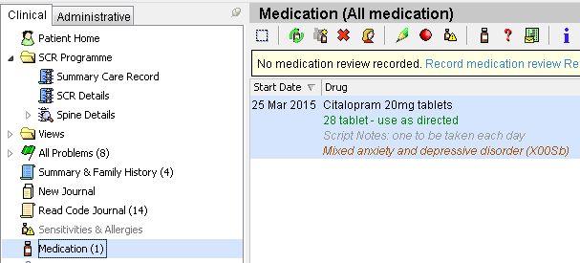
Problem item ‘Mixed anxiety and depressive disorder’ is displayed as the ‘Reason for medication’ for medication item ‘Citalopram’ on the SCR preview screen
Fig. 01
Summary Care Record preview
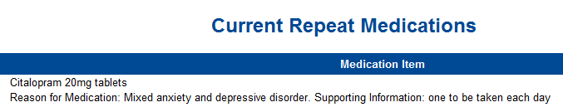
Fig. 02

- Active Problem items – items included as active major or active minor problems will be displayed in the SCR unless the coded item falls within the SCR exclusion dataset or it has been marked as private in the SystmOne record. Inactive problems are only displayed if the coded item has been included within the local summary, if the coded item forms part of the SCR inclusion dataset or has been manually included in the SCR.

Each active problem item on the SCR will be displayed twice – under the Problems and Issues Care Record Element (CRE) heading and also under its associated CRE heading (see Fig. 05).

GP Record
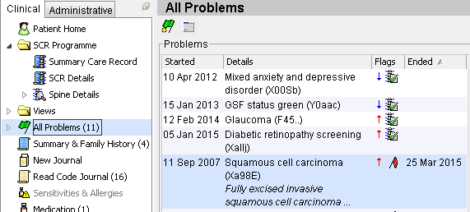
Active Major Problems in the SystmOne Record
Inactive Major Problem in the SystmOne Record
Active Minor Problems in the SystmOne Record
Fig. 03

- Active Summary items – items in the current local SystmOne Summary will be included in the SCR unless the summary item falls within the SCR exclusion dataset or it has been marked as private in the SystmOne record. Past Summary items are only included if the item has been marked as an Active Problem, if the coded item forms part of the SCR inclusion dataset or it has been manually included in the SCR.

Each active summary item on the SCR will be displayed once –under its associated CRE heading (see Fig 05).

GP Record
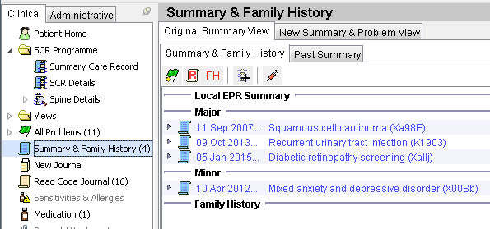
Active Summary items in the SystmOne Record
Fig. 04

Summary Care Record preview showing active problem items and current summary items
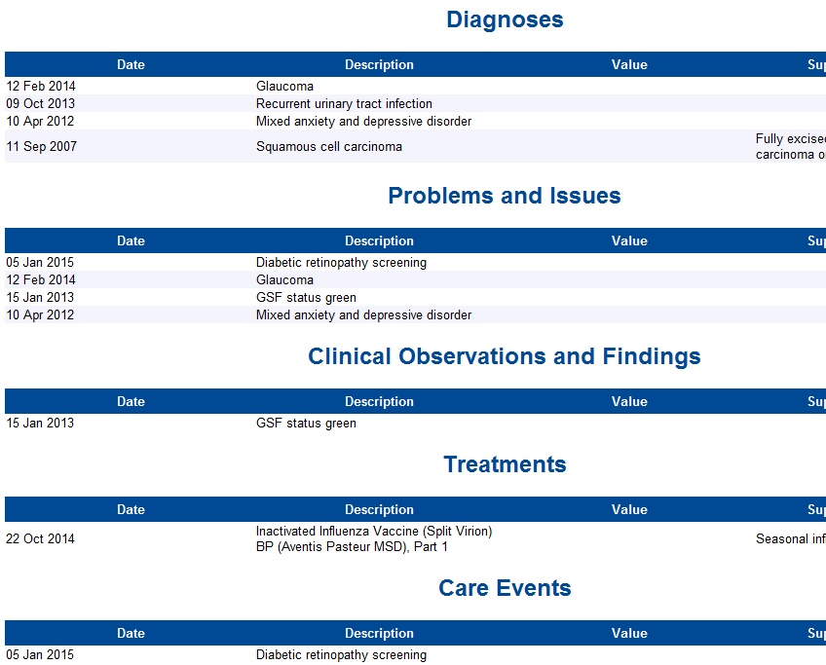
Example of a Problem item. This is displayed twice – under the Problems and Issues CRE heading and under the item’s associated CRE heading
Example of an Active Summary item. This is displayed once – under the item’s associated CRE heading
Fig. 05
- Vaccinations – all vaccinations recorded in the patient’s SystmOne record within the Vaccination node.

GP Record
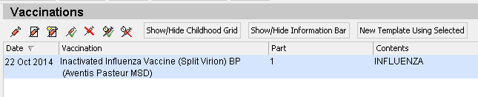
Vaccination in the GP Record

Summary Care Record preview
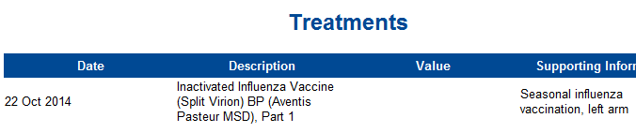
Vaccination displayed within the Treatments CRE heading

- SCR inclusion dataset - any coded item in the patient’s record from the generic list of specific coded items in the SCR inclusion dataset. For further information on the SCR inclusion dataset, see the section below on viewing the datasets in SystmOne and the Frequently Asked Questions at http://systems.hscic.gov.uk/scr/gppractices/additional

A specific list of coded excluded items is used to automatically exclude potentially sensitive items related to in-vitro fertilisation, sexually transmitted diseases, termination of pregnancy or gender re-assignment – as per the Royal College of GP’s sensitive dataset from the SCR. These can be manually added back to the SCR if the patient wants them adding.
To view the specific coded items in the generic Inclusion and Exclusion datasets:
- Select Setup>Reference>SCR Inclusion/Exclusion Sets from the Main Menu. The SCR Additional Item Data Sets dialog is displayed.
- Select the 'Inclusion Set' or 'Exclusion Set' tab, as required.
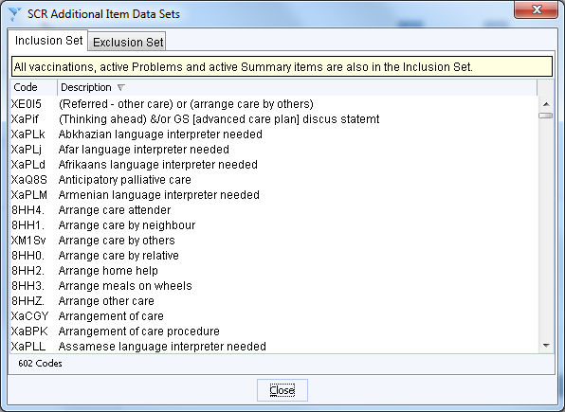

Existing patients with Additional Information when SCR v2.1 is first enabled
When SystmOne SCR v2.1 is first enabled, existing patients with Additional Information consent recorded will have their SCR supplemented with further Additional Information, when their SCR is next updated (due to a change in the core or Additional Information).

GP practices should confirm that the updated content reflects the information they have previously provided to patients. GP practices may wish to discuss the updated additional content with relevant patients to ensure that they are still happy with their SCR consent preference and/or SCR content. A leaflet to support discussions with patients is available for download from the HSCIC website at http://systems.hscic.gov.uk/scr/gppractices/additional.

To identify those existing patients that have Additional Information consent currently recorded, a report can be run. For guidance on running the report see page 2 of the SystmOne SCR v2.1 guidance.

Adding Additional Information
Additional Information should only be added with patient consent. The consent is enduring and the SCR will be automatically kept up to date with relevant information as the GP record is updated over time. To support discussions with patients regarding Additional Information, a leaflet is available for download from the HSCIC website at: http://systems.hscic.gov.uk/scr/gppractices/additional.
To record consent for Additional Information:
- Retrieve the patient record, ensuring that you are logged on with your Smartcard.
- Navigate to the 'SCR Details' node of the Clinical tree.
- Click the Edit Consents button on the toolbar (this is a Spine icon with a green tick) – the Edit SCR Consent dialog box is displayed:
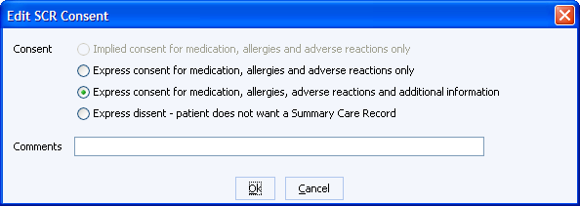
- Select “Express consent for medication, allergies adverse reactions and Additional Information” and click Ok.

A dialog box advises that “This patient may have additional items marked as included from the Summary Care Record. You should check these items are correct before saving the record.” The section Previewing and reviewing the SCR with Additional Information below describes how to preview the SCR and review data that is included and excluded. Once the consent is recorded on the system, the SCR is automatically populated with relevant Additional Information.

Previewing and reviewing the SCR with Additional Information
Once Additional Information has been added to the SCR it can be previewed.
To preview the local SCR, select the Summary Care Record node in the clinical tree. The local copy of the SCR is displayed. The coded items in the SCR, together with their supporting free text are grouped and displayed under CRE headings as shown below:
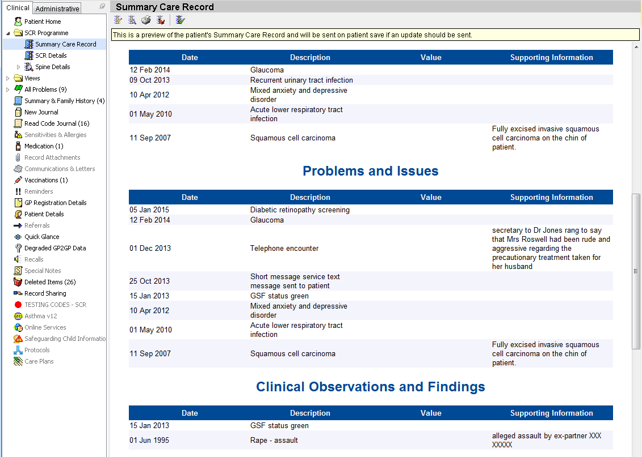Example of a Summary Care Record preview containing potential confidentiality, sensitivity and data quality issues. These can be reviewed as outlined below.
Potential for Data Quality issue
Potential for sensitive information inclusion
Potential for sensitive or 3rd party information
The way information is structured in the SystmOne record and the quality of the local summary determines the quality of the SCR. The content of the SCR with Additional Information may therefore be reviewed for:

- Confidentiality – check the supporting ‘free text’ of coded items in the SCR for inclusion of confidential information about the patient or a 3rd party. If you wish to remove the associated coded item from the SCR, you could change the item to be inactive or remove it from the local summary. Also SCR honours items marked Private in SystmOne and indicates the item as withheld from the SCR.
Suggestion for addressing the above ‘Telephone encounter’ example:
Locate the ‘Telephone encounter’ item in the Read Code Journal. This is a Problem item, so either right-click and select ‘End Problem’ or mark the item as private in the SystmOne record.
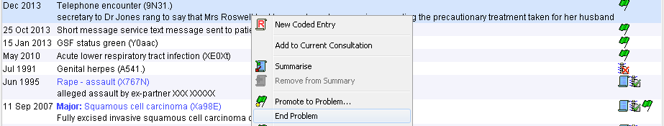
- Sensitive items – check for sensitive items. If you wish to remove the item from the SCR, you could change the item to be inactive or remove it from the local summary. Also SCR honours items marked Private in SystmOne and indicates the item as withheld from the SCR.
Suggestion for removing ‘Rape - assault’ in the above example:
Locate ‘Rape – assault’ item in the Read Code Journal. As this is a Summary item, right-click and select ‘Remove from Summary’, then ‘Move to past summary’.
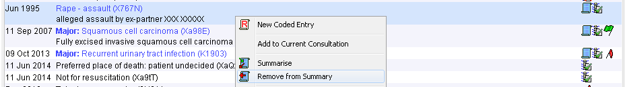
- Data quality – Unnecessary information in the active Problems or SystmOne Summary is not desirable in the SystmOne record or the SCR. In the example above, administrative information that has been previously recorded as an active Problem (the Short message service text message sent to patient) may be removed from active Problems (and the SCR) by ending the Problem. Other examples may include duplicate entries, DNA’s, ‘seen by A&E’ or health promotion information (e.g. advised to stop smoking, cervical smear overdue, etc.).
If it is felt that there are minor health problems that are not relevant to the SystmOne Summary, active Problems list (and the SCR) you may wish to correct this by ending the problem and ensuring that the item is not in the local summary.
- Completeness – To help ensure that relevant information is available in the SCR - including patient preferences. For example, the patient may wish to include ‘Preferred place of care…’ in their SCR. If it is included in the SystmOne Summary, then it will be automatically included in the SCR or alternatively it can be manually added to the SCR using the Amend Summary Care Record screen (see page 10) or right-click options in the Read Code Journal.
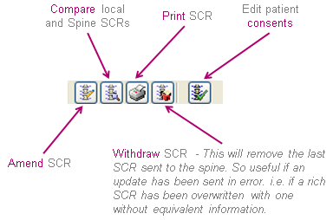
Patients can be given an opportunity to view their SCR with Additional Information on screen at the GP surgery. The SCR can be printed by clicking the Print SCR icon as below:
Other existing functionality includes the ability to compare the local copy of the SCR with the existing version on the Spine – press the Compare the Summary Care Record with Spine icon.

Amend Summary Care Record screen
The Amend SCR icon above invokes the Amend Summary Care Record screen shown below. This screen now includes:
- 'Included Items' – items currently included in the SCR
- 'Excluded Items' – existing items previously excluded using the pre-SCR v2.1 functionality.
- 'Exclusion Set Items' – items currently automatically excluded from the SCR.
These sections allow the user to see the relevant coded items from the patient’s record and whether they are currently included or excluded from the SCR.
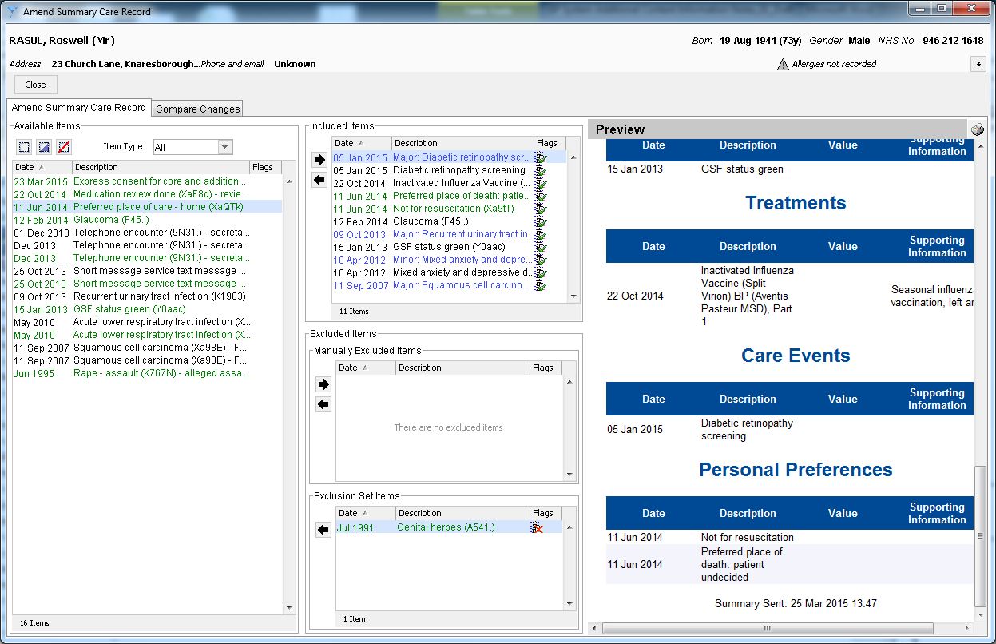
Amend Summary Care Record Screen
The Available Items list on the left can be reviewed to identify any items that should be added to the SCR. Such items can be added to the SCR by selecting the item(s) and clicking the right arrow on the Included Items list. Conversely, manually added items can be removed from SCR by selecting the item(s) in the Included Items list and clicking the left arrow.
Automatically excluded Items can be added to the SCR by selecting the item(s) in the Exclusion Set Items list (at the bottom of the middle pane) and clicking the left arrow. This moves the items into the Included Items. Sensitive items from this list should only be added to the SCR with the patient’s consent.
Alternatively, items can also be added from within the Read Code Journal in the patient record. To add an item from the Read Code Journal, right-click on the item (e.g. the automatically excluded item Genital herpes below) and select Add to Summary Care Record.
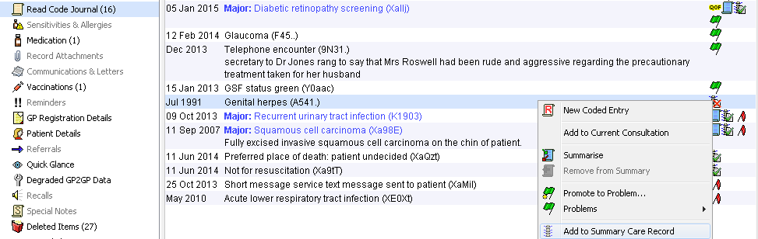
If a later decision is made to remove the manually added item, right-click on the Read code and select Exclude from Summary Care Record. This will remove the item from the SCR.
Manual exclusion of items from the SCR only applies to manually added items and it is not possible to manually exclude any of the automatically included information from the SCR. However, items marked as private in the SystmOne record are not included. For these items, a message is displayed in the SCR stating ‘One or more items have been deliberately withheld from this GP Summary’.
The SCR can be previewed via the Summary Care Record node as each amendment is made or at the end of the process as required:
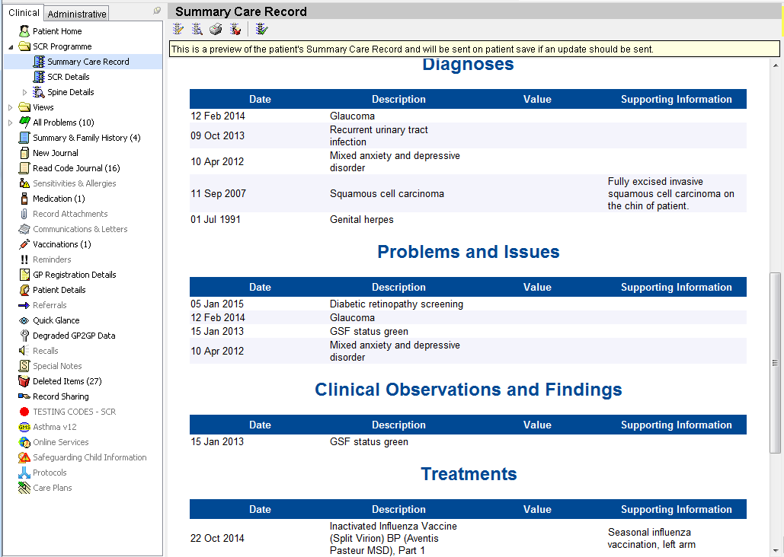
Example of a Summary Care Record preview after confidential and sensitive information and data quality issues have been addressed.
After previewing and checking the SCR with Additional Information, click the Save button to send the SCR to the Spine.
Inclusion and Exclusion flags
Relevant sections of the patient record contain flags indicating if items are included or excluded from the SCR. This includes the Read Code Journal – as shown below:
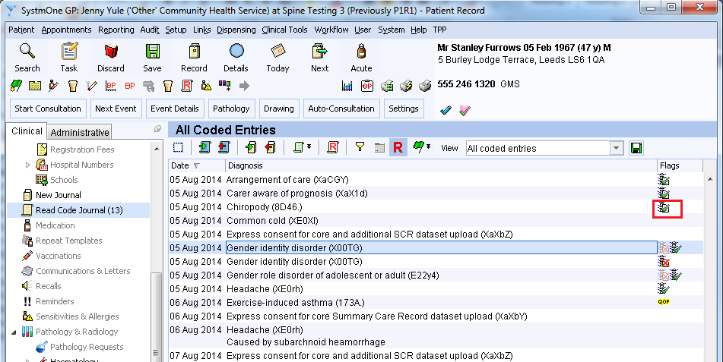

What do the flags mean?

This indicates an item that is included in the SCR.

No Flag indicates the item is not included in the SCR. It could be manually added if considered relevant.

This indicates the item is a sensitive item and is currently automatically excluded from the SCR. It could be included, but only with patient consent.

This indicates the item is a sensitive item that was automatically excluded from the patient’s SCR but was manually included by the GP with patient consent.

The flags are also visible in the SystmOne records of patients who have not yet consented to Additional Information – but they are greyed out and the information is not on the SCR. This can be useful for seeing what information would be added to the patient’s SCR if consent was given by the patient and recorded on the system:
