Summary Care Record Quick Guide
EMIS Web SCR v2.1

Contents
Introduction 2
Additional Information – the improved mechanism 2
How does EMIS Web populate the SCR Additional Information content? 2
1. Reason(s) for medications 2
2. Active Problem items and Significant Past Problem items 2
Existing patients with Additional Information consent when SCR v2.1 is enabled 2
Previewing the patient’s (potential) SCR with Additional Information 2
Local Preview 2
Adding Additional Information to the patient’s SCR 2
To record consent for Additional Information 2
Reviewing and Managing the content of Additional Information 2
Manually including items 2
Saving the SCR 2

Introduction
SCR v2.1 in EMIS Web introduces new functionality:
- Improved SCR update functionality on full patient (GMS) registration: On registration completion; if the patients GP record contains relevant SCR information, then an updated SCR is automatically created. The SCR section of Workflow Manager has been modified, to simplify your SCR workload. The New Patients section has been removed and it is not necessary to deal with these items separately. Summaries for newly registered patients are displayed in the Summaries Awaiting Send section, and then sent, even if patients already have an SCR on the Spine, which the new summary will overwrite. For new patients prior to registration completion; practices are encouraged to use the existing Emis Web functionality for viewing SCRs for temporary patients to view the last SCR sent from the previous practice. For further information, see:

- SCRs with Additional Information are now supported for those patients who provide consent for this. It can be used to benefit patients approaching ‘end of life’, the “frailest 2%” and those with long term conditions or communication problems such as learning disabilities or dementia; or indeed any patient who feels that it would be beneficial to have Additional Information about their care/health added to their SCR.
For practices performing an initial upload of SCRs, any patients with consent for Additional Information will have Additional Information added during the initial upload.

Additional Information – the improved mechanism
Adding Additional Information remains within the control of individual patients and their GPs. The patient’s ‘express consent’ is required for Additional Information to be included on the SCR. If the patient’s consent for Additional Information is recorded in the system, the SCR can contain:
  - The core information of Medications, Allergies and Adverse Reactions, plus the reason for medication.
  - Further relevant information pertaining to:
    - Significant medical history (past and present)
    - Significant procedures (past and present)
    - Anticipatory care information
    - Palliative Care coordination information – as per dataset SCCI1580
    - Immunisations
- The information added to the SCR will consist of coded items from the GP record with their supporting free text. Users should preview the SCR content to ensure that sensitive information is not included.
- Further individual items may be included in addition to those above. These can be added manually, but only with the patients express consent. See Adding Manual items below.
- The SCR will be automatically kept up to date with the relevant information above as the GP record is updated over time.
- Patients can be reassured that potentially sensitive items (specifically related to IVF, STDs, terminations, gender re-assignment) are automatically excluded unless the patient wants them including. If so, the patient must provide consent for their GP to add them.
- The EMIS implementation of the relevant Additional Information is described below – See Additional Information Content - Inclusion and exclusion information.
For further detailed guidance on SCR v2.1 in EMIS Web, see the EMIS SCR v2.1 Support Centre documents

How does EMIS Web populate the SCR Additional Information content?
There are five ways in which EMIS Web automatically includes items on the SCR:
- Reason(s) for medication
- Active Problem items and Significant Past Problem items
- Immunisations
- EMIS datasets for:
    - Significant Previous Procedures
    - Anticipatory Care Information
    - End of Life Care Information
    - Other inclusion dataset items
- NHS Digital SCR inclusion dataset

Reason(s) for medications
Any problem that has been linked to a medication will be displayed in the SCR with the associated medication, unless the problem item falls within the SCR exclusion dataset or it has been marked as confidential in the EMIS Web record.
GP Record
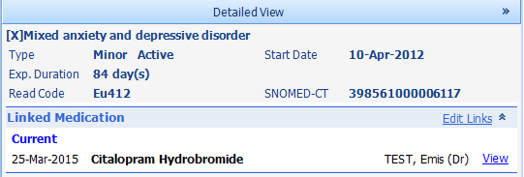
Problem item ‘Mixed anxiety and depressive disorder’ is linked to medication ‘Citalopram’ in the EMIS Web record

Summary Care Record Preview
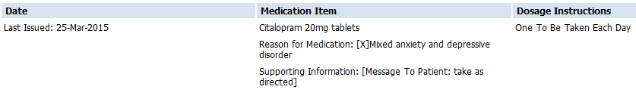
Problem item ‘Mixed anxiety and depressive disorder’ is displayed as ‘Reason for medication’ for medication ‘Citalopram’ on the SCR preview screen

Active Problem items and Significant Past Problem items
Items recorded as active significant, active minor or past significant problems will be included in the SCR unless the coded item falls within the SCR exclusion dataset or it has been marked as confidential in the EMIS Web record. Past minor problems are only included if the coded item forms part of an EMIS dataset, part of the HSCIC SCR inclusion dataset or it has been manually included in the SCR.
Each problem item on the SCR will be displayed twice – under the Problems and Issues Care Record Element (CRE) heading and also under its associated CRE heading.
GP Record
Active Significant Problem in the EMIS Web record
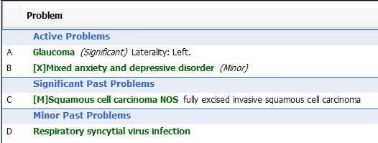
Minor Past Problem in the EMIS Web record
Significant Past Problem in the EMIS Web record
Active Minor Problem in the EMIS Web record

Summary Care Record Preview
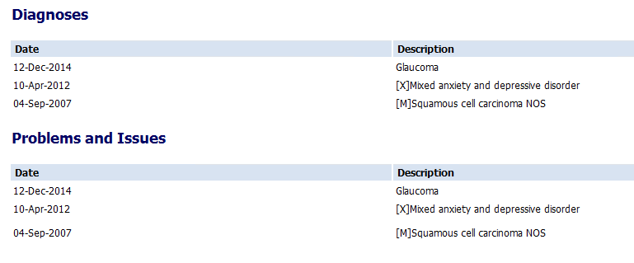
Active Problems and Significant Past Problems are displayed in the Summary Care Record
Each Problem item is displayed twice – under the Problems and Issues CRE heading and under the item’s associated CRE heading
- Immunisations
All immunisations recorded in the patient’s EMIS Web record will be displayed under the Treatments CRE heading.
GP Record
Vaccination in the EMIS Web record

Summary Care Record Preview
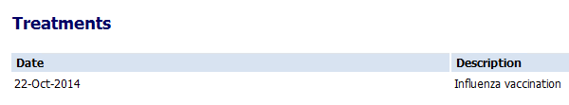
Vaccination displayed within the Treatments CRE heading in the SCR preview
- EMIS datasets
- Significant Previous Procedures – any coded item in the patient’s record that falls within Read chapter 7 with exclusions of sub chapters 7Q, 7N and 7P.
- Anticipatory Care Information – the most recent five (rolling) instances in the patient’s record of the Key Information Summary (KIS) codes.
- Palliative Care coordination Information – Latest (rolling) instance in the patient’s record of SCCI1580 codes plus EMIS end of life and palliative care coordination template codes.
- Other Inclusion Dataset items - the most recent five (rolling) instances in the patient’s record of a specific coded list defined by EMIS to catch items not covered in other parts of Additional Information e.g. blood pressure, height.
If any of the above coded items fall within the SCR exclusion dataset or if they have been marked as confidential in the EMIS Web record they won’t be automatically included.
Further detail concerning the specific content of Additional Information in EMIS Web is available in the EMIS Support Centre document SCR upload consent and the initial upload 2.1.
- NHS Digital SCR Inclusion Dataset
Any coded item in the patient’s record from the generic list of specific coded items in the SCR inclusion dataset. For further information on the dataset, see:
A specific list of coded excluded items is used to automatically exclude potentially sensitive items related to in-vitro fertilisation, sexually transmitted diseases, termination of pregnancy or gender re-assignment – as per the Royal College of GP’s sensitive dataset, from the SCR. These can be manually added back to the SCR if the patient wants them adding.
To view the specific coded items in the generic Inclusion and Exclusion datasets, please use these links:
Inclusion dataset:
Exclusion dataset:

Existing patients with Additional Information consent when SCR v2.1 is enabled
When SCR v2.1 is enabled, existing patients with Additional Information consent recorded will have their existing SCR supplemented with Additional Information when their SCR is next updated (due to a change in the relevant core or Additional Information).

GP practices may wish to discuss the updated additional content with relevant patients to ensure that they are still happy with their SCR consent preference. A leaflet to support discussions with patients is available for download from the NHS Digital website at https://digital.nhs.uk/summary-care-records/additional-information

To identify those existing patients with Additional Information consent, reports can be run. Navigate to; Population Reporting > EMIS Library > Summary Care Record Consent. Identify the following report(s): SCR Consent Preference is 9Ndn (Express consent + Additional) and SCR Consent Preference is 93C2 (Legacy express consent)

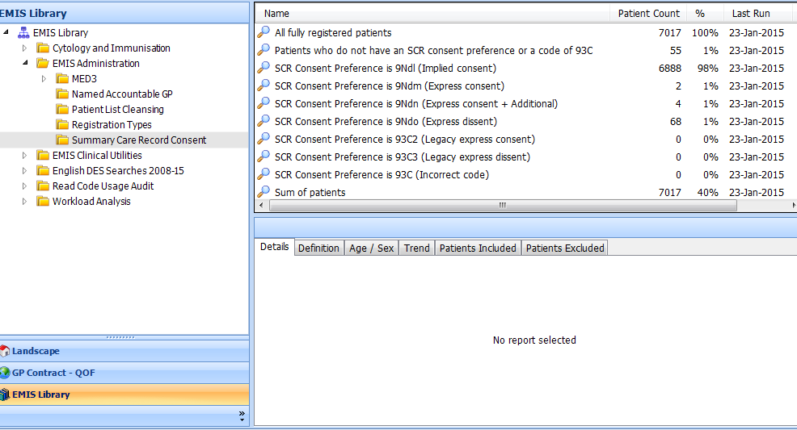

Run this report to find the number of patients which will have their SCR supplemented with Additional Information when their GP record is next updated following the SCR v2.1 update.

Previewing the patient’s (potential) SCR with Additional Information
EMIS Web can show the patients potential SCR with Additional Information before the patients consent is recorded in the system and the information has been added to the existing SCR on the spine. This allows a clinician to see the information that will be added to benefit the patient and can be used to show patients what their SCR will look like. This functionality is available through the SCR Viewer:
- Access Care Record and select the required patient.
- If required, click at the left-hand side of the screen to expand the shared records pane.
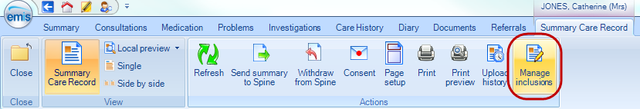
- In the External Views section of the shared records pane, select Summary Care Record.
- Click the Local preview button and select either:
  - Medication, allergies and adverse reactions or
  - Medication, allergies, adverse reactions AND Additional Information

Local Preview
Clicking the Local preview button invokes the Local Preview screen. From here the core SCR and/or SCR with Additional Information can be viewed either singularly (Single) or Side by Side to compare the local SCR content with the Spine SCR content. The coded items added to the SCR and their supporting free text are grouped and displayed under headings.

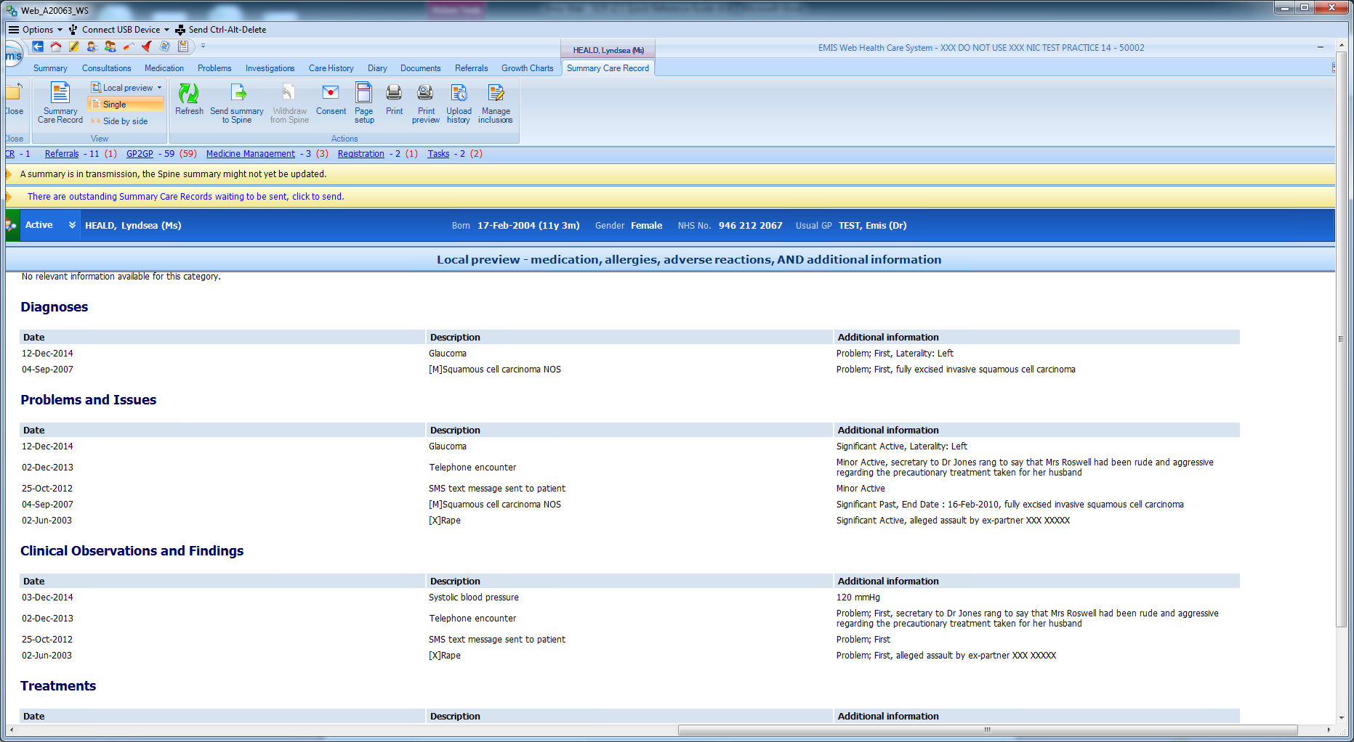
Potential for sensitive information inclusion
Potential for Data Quality issue
Potential for sensitive or unnecessary 3rd party information
Example of a Summary Care Record preview containing potential confidentiality, sensitivity and data quality issues. These can be reviewed as outlines below.

The way information is structured in the EMIS Web record and the quality of the data entered determines the quality of the SCR. The content of the SCR with Additional Information may therefore be reviewed for:

Confidentiality
Check the supporting ‘free text’ of coded items in the SCR for inclusion of confidential information about the patient or unnecessary 3rd party information. If you wish to remove the associated coded item from the SCR and it is a Problem item, you could change the problem status to ‘End Problem’ or ‘Not a Problem’. Also SCR honours items marked Confidential in EMIS Web and indicates the item as withheld from the SCR.
Suggestion for addressing the above ‘Telephone encounter’ example:
As this is a Problem item, locate ‘Telephone encounter’ on the Problems screen, right-click and select ‘End Problem’ or mark the item as Confidential in Care History.
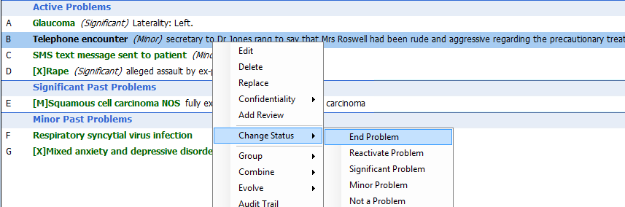

Sensitive items
Check for sensitive items. If you wish to remove the associated coded item from the SCR and it is a Problem item, you could change the problem status to ‘End Problem’ or ‘Not a Problem’. Also SCR honours items marked Confidential in EMIS Web and indicates the item as withheld from the SCR.
Suggestion for removing the above ‘Rape’ example:
Locate ‘Rape’ on the Care History screen, right-click and select ‘Confidentiality’ > ‘Change Policy’.
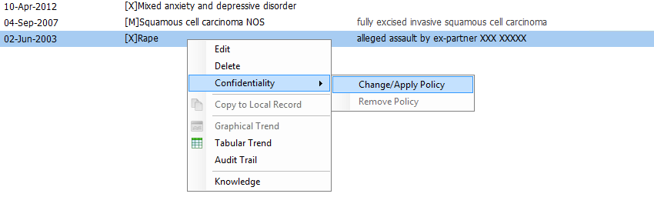

Data Quality
Unnecessary information in the active Problems or significant past Problems is not desirable in the EMIS Web record or the SCR. In the example above, administrative information that has been previously recorded as an active Problem (the SMS text message sent to patient) may be removed from active Problems (and the SCR) by right-clicking the Problem and selecting ‘Not a Problem’. Other examples may include duplicate entries, DNA’s, ‘seen by A&E’ or health promotion information (e.g. advised to stop smoking, cervical smear overdue, etc.).
If it is felt that there are minor health problems that are not relevant to the active Problems list (and the SCR), you may wish to correct this by ending the problem.

Completeness
This is to help ensure that relevant information is available in the SCR – including patient preferences. For example, the patient may feel that the ‘Emergency contact details’ held in their GP record should also be present in their SCR. These will be automatically included if they are recorded as an active problem, alternatively the coded item can be manually added to the SCR using the Manage SCR screen (see page 10).

Patients can be given an opportunity to view their SCR with Additional Information and it can be printed by clicking the Print button.

Adding Additional Information to the patient’s SCR
Additional Information can only be added with patient consent. To support patient discussions regarding Additional Information, a leaflet is available for download from the NHS Digital website at https://digital.nhs.uk/summary-care-records/additional-information

To record consent for Additional Information
- Select the required patient.
- The Patient Consent Preference screen can be accessed by any of the following ways
    - From the expanded patient précis, click the SCR consent hyperlink.
    - From any area of Care Record except Medication, click Sharing on the ribbon and select SCR Consent.
    - From Medication, click Patient Actions on the ribbon, point to Sharing, and then select SCR Consent.
    - From Consultation Mode, click Sharing on the ribbon and select SCR Consent.
    - From Registration, click Sharing Consent on the ribbon and select Summary Care Record.
    - From the SCR Viewer screen, either click Consent on the ribbon or click the consent hyperlink at the bottom of the screen.
The patient’s current consent preference will be displayed at the top of the ‘Patient consent preference – Summary care record’ screen.
- Select “Express consent for medication, allergies, adverse reactions, AND Additional Information”
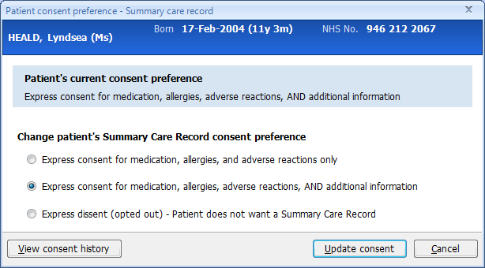
- In the Reason for Change field, type the reason for the change of preference.
- Click Update consent. A warning message is displayed, reminding you to make sure that the patient understands the implications of their choice.
- To continue click Yes and the patient’s consent preference is updated.
Once the consent has been set, the Additional Information is added to the local copy of the SCR. For further information on consent in SCR see the EMIS support centre document SCR patient consent 2.1 or at http://systems.hscic.gov.uk/scr/gppractices/additional
Before the SCR with Additional Information is saved to the spine, the content of the SCR with Additional Information should be reviewed for completeness and data quality – For further information see the Local Preview section above. The SCR is made available to be viewed by clinicians providing direct care for the patient but, as a broad principle, when patients provide their informed consent to additional information there should be ‘no surprises’ if the patient were to view the information.

Reviewing and Managing the content of Additional Information
A new ribbon option Manage Inclusions is available on the Summary Care Record ribbon:
Clicking Manage Inclusions invokes the Manage SCR screen:
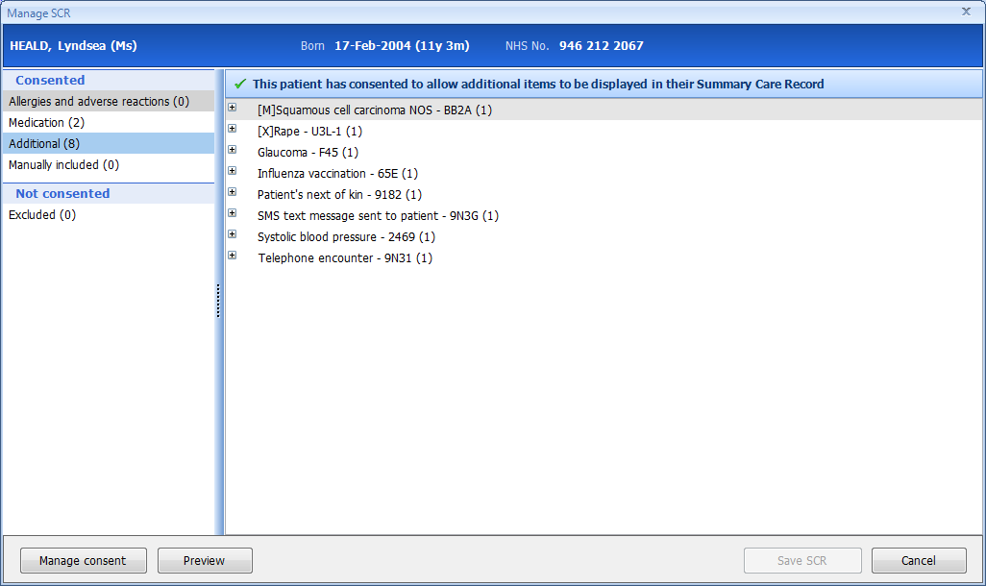

This screen allows the user to:
- Review the specific codes included in the SCR and those currently excluded as they are part of the RCGP sensitive dataset – make a selection on the left of the screen and applicable items will be displayed on the right
- Preview the SCR as it will look on the spine
- Manually Add coded items (and Remove a coded item)
- Review and Manage consent
- Save SCR to the spine

Manually including items
Further items can be manually added to the SCR. This can be used to include relevant items not automatically included or items in the exclusion dataset that the patient would like adding to the SCR.

Adding coded items to the SCR
- Ensure ‘Manually included’ is selected in the left hand panel, then click
- This will open a dialog from which relevant items may be selected
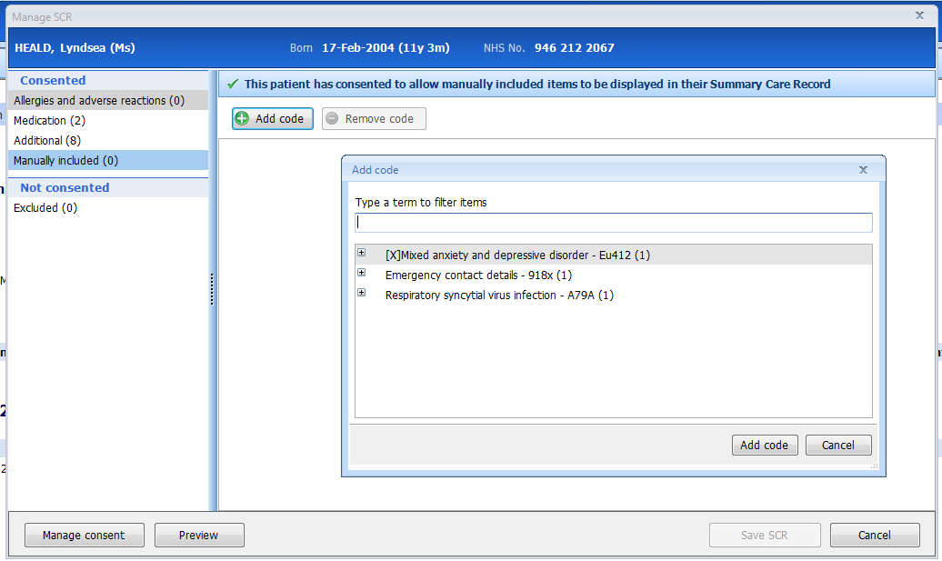
- Click/highlight the item that you would like to add, then click the Add code button
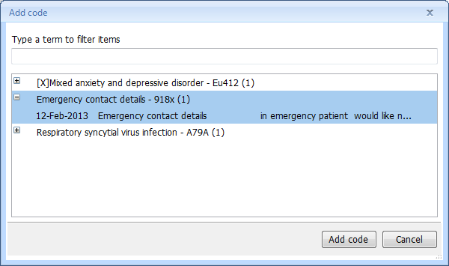
- The items added will be reflected in the Manually Included list on the left hand side.
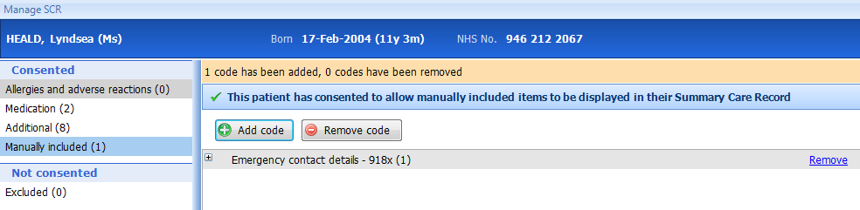
- To add an automatically excluded sensitive item to the SCR, click Excluded() on the left hand panel
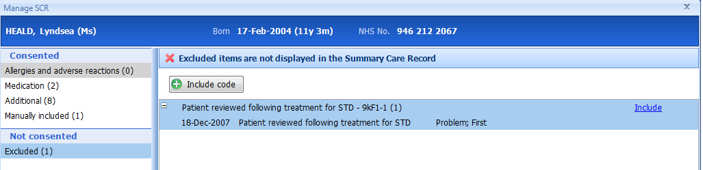
- Select an excluded item from the list and click . The item will be added to the Manually Included list.
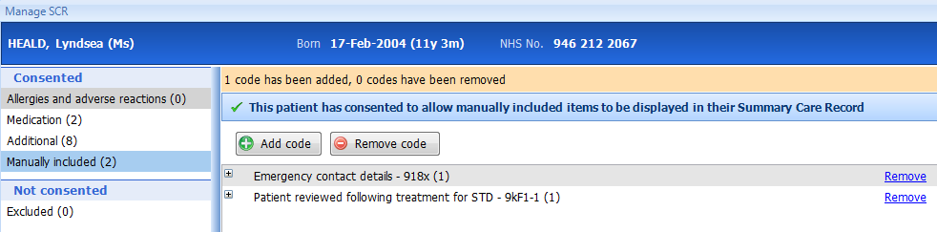

Removing manually added items from the SCR
If a further decision is made to remove the manually added item, then
- Ensure ‘Manually included’ is selected in the left hand pane
- Click/highlight the item that you would like to remove, then click
- The item will be removed from the Manually included list
Removal of coded items from the SCR only applies to manually added items and it is not possible to remove automatically included information from the SCR. Items marked confidential in the GP patient record are not added to SCR. For confidential items, the date is displayed in the SCR, together with ‘Item not available’.

Saving the SCR
Clicking the Save SCR button, results in the updated summary being sent to the Spine.
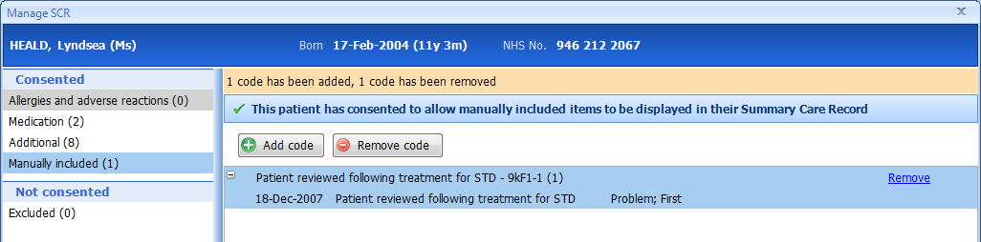

In order to change a patient’s consent status for their Summary Care Record, staff will need the activity B0020 on their smartcard.

