User Guide for Acceptance of a Digitalised Connection Agreement/Contract via the ServiceNow Customer Portal

Introduction to the Digitalised Connection Agreement/Contract
As part of NHS England’s ongoing efforts to improve our service and streamline our processes, we have transitioned to a fully digital system for managing Connection Agreements effective from 1st August 2025. This transition will be facilitated through our ServiceNow Customer portal.
Version 6 of the Connection Agreement/Contract is held against your (connecting party) registered account in ServiceNow.
The Connection Agreement/Contract is a downloadable document accessible via the customer portal here that contains terms and conditions that are applicable to NHSE Services/ API.
New contract (contains new API Products Applicable or removal of some API Products previously applicable due to offboarding)
Signatures have been replaced with an acceptance state of “Active” and date “Accepted on” will contain the registered onboarding contact name who has accepted the terms and conditions under “Accepted By”.
A case is created to allow you to communicate with NHSE connection agreement team.
You have 90 days to accept the connection agreement. If the connecting party accepts the connection agreement the state will change to “Active”. The case automatically resolves when the connection agreement has been accepted and is at state “Active”.
If the connection agreement is not accepted within the 90-days review period, the state will change to “Cancelled”. This means a new connection agreement request will need to be raised if still required. You will need to contact the NHSE API product onboarding team to arrange for creation of a new connection agreement.
Terms change (uplifted contract changing terms and conditions)
When terms and conditions are modified with a new version number the system will automatically generate an uplifted version of existing connection agreements containing these terms and conditions and will issue notifications to all connecting parties.
This is an automated acceptance process, after the 30-days review period the system will automatically change state to “Active”. If you have any questions regarding the terms change, you can raise a query within the 30-days review period, this will create a case, the NHSE connection agreement team can stop the 30-days timer to allow time for your questions to be answered. Once resolved, the NHSE connection agreement team can reset the automated acceptance process, and the system will automatically change the state of the connection agreement to “Active”.
All query communications will be via a “case” and the case will be recorded against the Connection Agreement/Contract.
Previous Connection Agreement/Contract state will change to “Expired”.
Contract termination (due to offboarding of all API Products previously applicable)
The NHSE connection agreement team will terminate the Connection Agreement/Contract, with an agreed end date. The state of the connection agreement will change to “Expired”.

How will NHSE issue the Digitalised Connection Agreement/Contract?
When your Connection Agreement/Contract is ready, an email notification will be issued from support.digitalservices@nhs.net containing a link to the customer portal that will display your Connection Agreement/Contract(s).
You will be issued a notification for the connection agreement updates listed below.
- New contract, contract awaiting acceptance containing new API Products Applicable or removal of some API Products previously applicable due to offboarding.
- New contract, contract awaiting acceptance containing existing API Products Applicable previously signed for v5 to uplift you to v6 which has been digitalised.
- Terms change, new contract version because of terms upliftment.
- Contract termination, due to offboarding of all API Products previously applicable.

How can I prepare myself for receiving the Digitalised Connection Agreement/Contract?
You must be registered with an account to view the connection agreement via the customer portal for further assistance on how to use the portal, please see guidance.
The guidance provides instructions how to self-register for an account if you do not have access to the portal.
To accept the connection agreement, you must be registered with responsibility of Onboarding Contact by completing the Supplier Onboarding Contact Nomination Form. You can search on the customer portal here by typing Supplier Onboarding Contact Nomination. Completion of this form automatically updates the user as an Onboarding Contact.
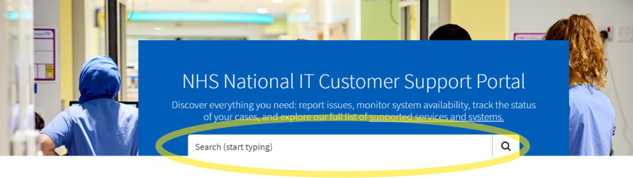

How to access the Connection Agreement/Contract
You can obtain your Connection Agreement/Contract history at any time by logging onto the customer portal and navigating to “My Extras” and “My Connection Agreements”.

Navigate to My Extras
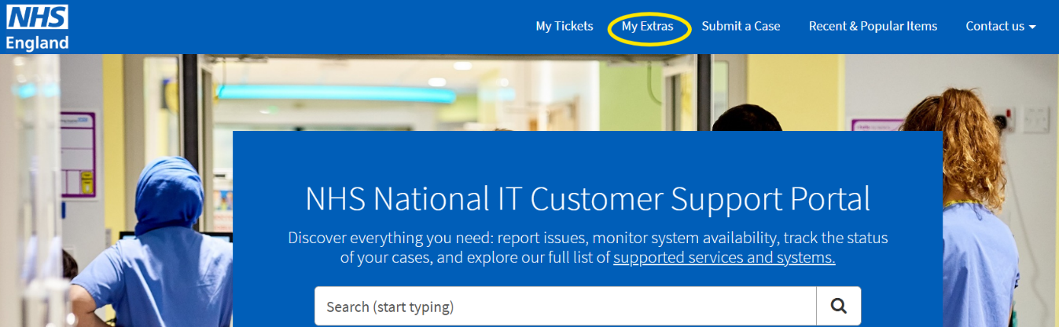
Navigate to My Connection Agreements
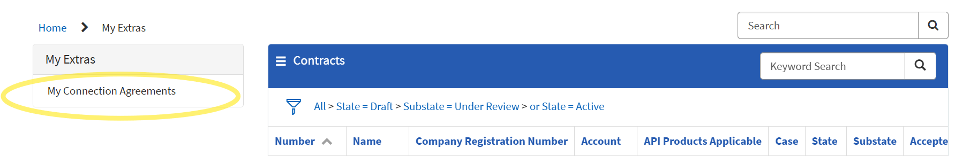
The filter settings by default shows all connection agreement states “Active” and “Draft” with substate “Under Review”.
You can see all previous Connection Agreement/Contracts including state “Cancelled” and “Expired” by removing filters (clicking “Clear All”) as shown in screen shots below.
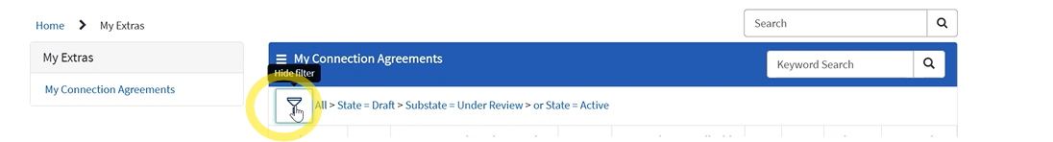
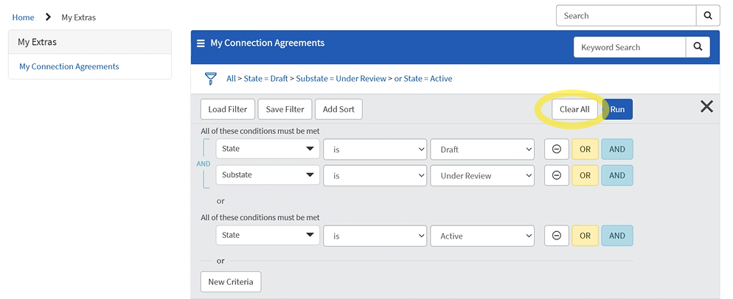

Number
This is a unique reference number for the contract record created in ServiceNow when NHSE creates a new Connection Agreement/Contract. The number will begin with CNTR followed by a 7-digit number.
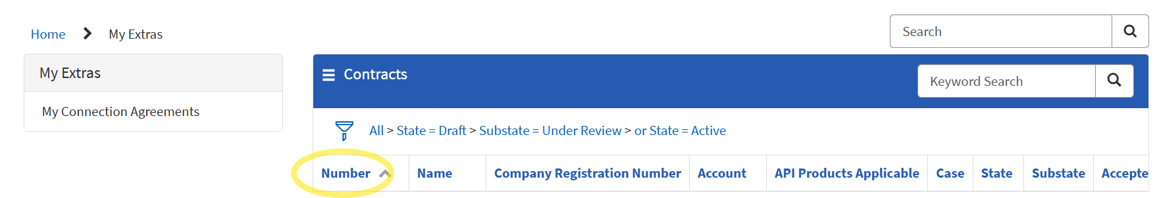
Select the contract number to view the contents of the Connection Agreement/Contract. Further information on this process is available under the Review/accept the Connection Agreement/Contract terms and conditions section.

Name
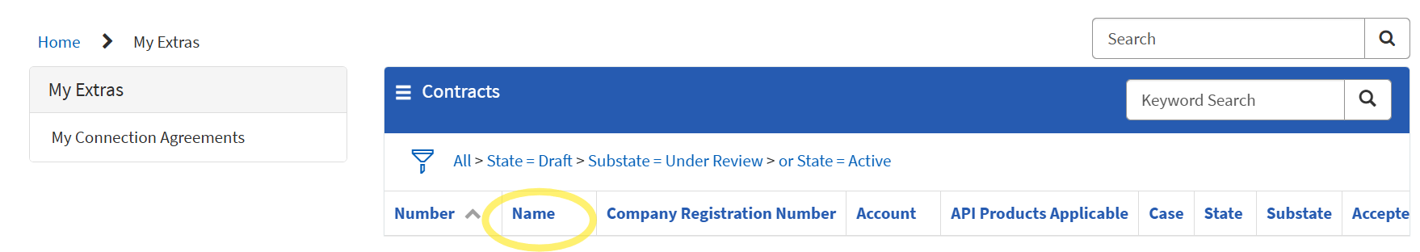
NHSE will create the name using a combination of your ODS code and Account name (Connecting Party Organisation Name).

Company Registration Number
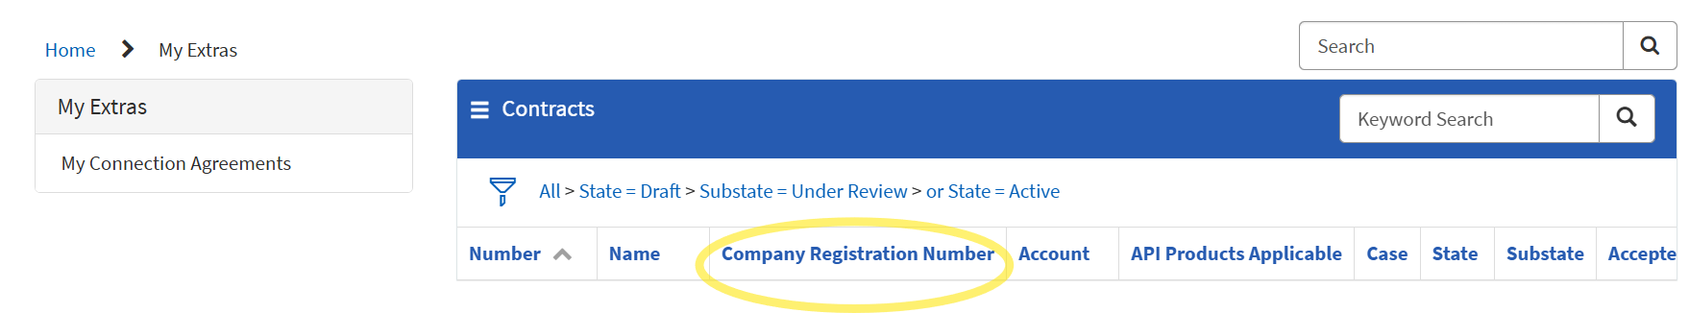
NHSE have searched your Account name and registered address in Service Now and ODS portal information to find your registered company number using Find and update company information - GOV.UK. Please check your company registration number is correct and contact us via a case if this is incorrect before accepting.
If you are a public healthcare organisation or registered outside of the UK, the ODS code will replace the Company Registration Number.

Account
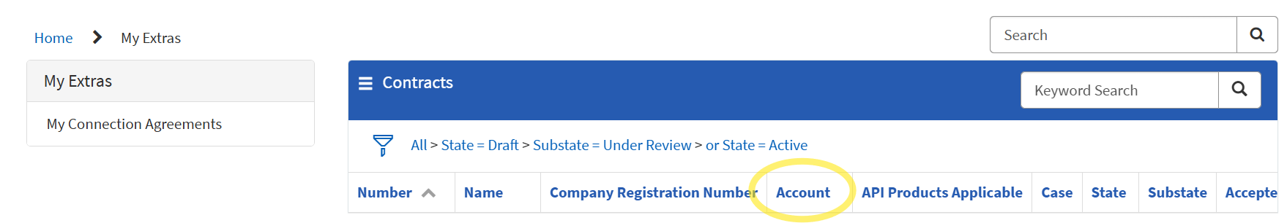
The Account (Connecting Party Organisation Name) is as registered in ServiceNow containing the ODS code which has been submitted within the SCAL (Supplier Conformance Assessment List). The SCAL may be completed via an excel doc or via our Digital Onboarding Service. The Connection Agreement/Contracts will be linked to this account.

API Products Applicable
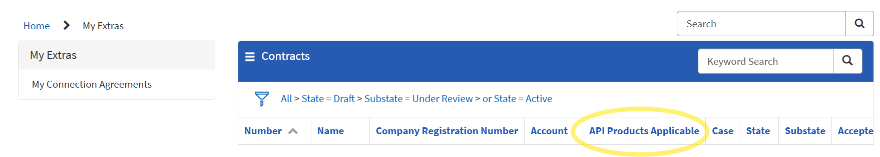
The API Products Applicable are the NHSE Services/ APIs that your product/s are approved to connect by completing the conformance documentation via the excel SCAL or Digital Onboarding Service.

Case
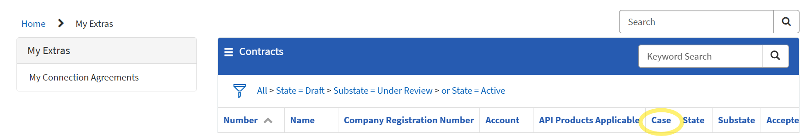
A case is created automatically when a Connection Agreement/Contract is created for new contract update to “API Products Applicable”, which is signature type “Accepted via Portal”.
The case can be accessed via the customer portal. This is for communication between the connecting party and NHSE Connection Agreement/Contract creation team.
A case is not created automatically on a terms change, which has Signature type “Auto Accepted”. To open a case to query terms change you will need to use the option “Raise a query”.
Further information on this process is available under the Review/accept the Connection Agreement/Contract terms and conditions section.
State
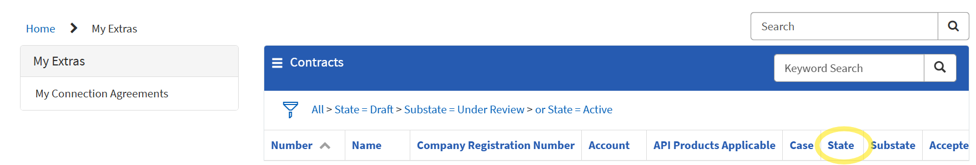
“Draft”
New Contract, signature type “Accepted via Portal” - The state will remain for 90 days or until the contract is accepted by the onboarding contact. If not accepted within 90 days, the Connection Agreement/Contract state will be automatically set to “Cancelled”.
Terms Change, signature type “Auto Accepted”. The state will remain for 30 days. This Signature type is used as we may update, from time to time, the terms and conditions following a policy/process review. If this happens the onboarding contacts will be notified via the customer portal and those changes will be published under referenced documentation, Connection Agreement Published Changes here. The system will allow 30 days to review and will be set to auto accept.
After 30 days, the Connection Agreement/Contract state will be automatically set to “Active”. If a query is raised the NHSE Connection Agreement/Contract team will pause the 30 days auto acceptance until the query is resolved.
“Active”
New Contract, signature type “Accepted via Portal”. The state will be changed to “Active” when the onboarding contact Accepts the Connection Agreement/Contract. “Accepted By” field will be populated by the name of the onboarding contact and “Accepted On” field will be populated with date accepted.
Terms Change, signature type “Auto Accepted”. This state is auto populated to “Active” when the previous version is replaced with new contract number, containing new version of terms and conditions following the 30-day review period.

“Expired”
This state is auto populated when the previous version is replaced with new contact number, containing new version of terms and conditions or additional “API Products Applicable” have been added.
This state is also used when the contract has been terminated due to offboarding where the “API Products Applicable” are no longer in use. The contract will contain an end date.
“Cancelled”
This state is Auto populated if the Draft (under review) state with Signature type “Accepted via Portal” has not been accepted by the onboarding contact within 90 days review and acceptance period.

Substate
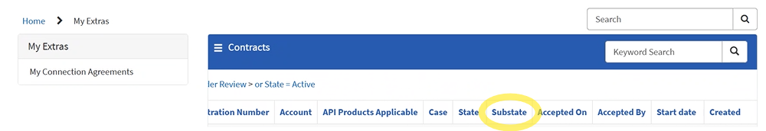
“Awaiting Review” with State “Draft” appears when the Connection Agreement/Contract is work in progress and being prepared by NHSE Connection Agreement/Contract team. The NHSE Connection Agreement/Contract team will not have yet issued email notification. You do not need to take any action until you have received an email notification from support.digitalservices@nhs.net.
“Under Review” with State “Draft” appears when the Connection Agreement/Contract is ready for the supplier to review and approve. An email notification will be issued from support.digitalservices@nhs.net to the onboarding contact containing a link to the customer portal that will display your Connection Agreement/Contract(s).

Accepted On
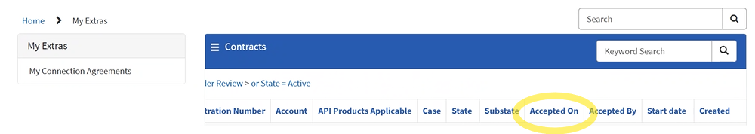
This is the date on which the onboarding contact has accepted the terms and conditions via the customer portal for a new contract, by ticking the box show in the screen shot below. This may also be the date that the system has auto accepted after 30 days review period following a terms change.

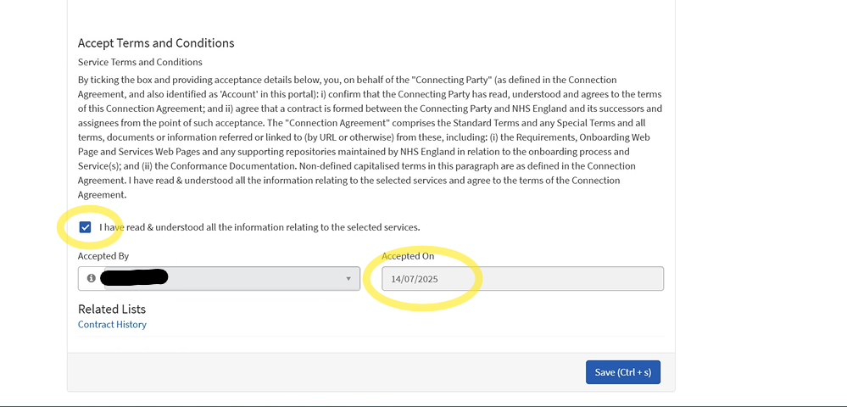

Accepted By
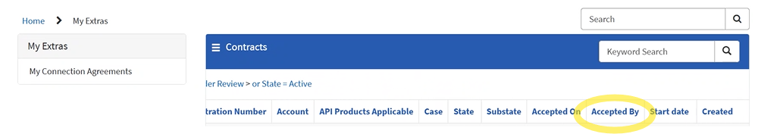
This will display the name of the person that has accepted.
Name will not appear if this is a terms change as the system will automatically accept after 30 days. The download PDS version of the Connection Agreement/Contract will show the name/s or email address that the terms change review was issued too.
Further information on this process is available under the Download PDF version Connection Agreement/Contract for review section.
Start Date
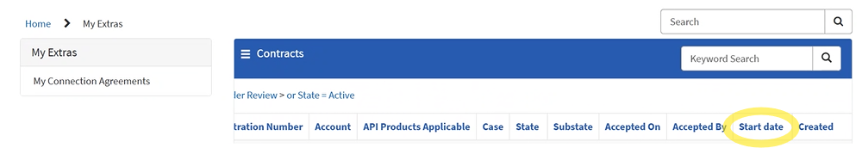
This will be updated with the date when your Connection Agreement/Contract has gone to state “Active”.

Created
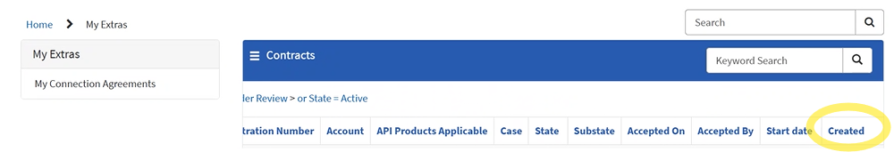
This will be the date including time stamp when the NHSE Connection Agreement/Contract team has created the Connection Agreement/Contract. This is also day 1 of the 90 days/30 days connection agreement review period.

Review/accept the Connection Agreement/Contract terms and conditions
Select the contract Number (this will be reference in your notification email). The number will begin with CNTR followed by a 7-digit number. The state will be Draft (under review).
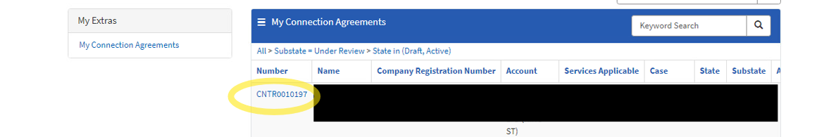
- Standard terms are applicable to all NHSE Services/ APIs.
- Special terms are applicable to specific, NHSE Services/ API and this will be clear on the heading of the Appendix.
- Note and share the contents of the End User Organisation Acceptable Use Policy (Appendix 1A,) with all your customers who will use your Product(s) to access any of NHS England Services covered by this Agreement. You will also need a business-as-usual process for sharing this Policy with new customers. A standalone copy of this Policy is available here. “End User Organisations” means any recipient or commissioning body using or commissioning a Connecting Party’s products or services which interface with Service(s) (whether directly, or indirectly via an agent or other commissioning body).

The acceptance section is at the bottom of the terms and conditions. See screen shot below.
***See “State” section, “Draft (Under Review)”.
You will only be asked to select the tick box to state you have read and understood, this will then auto populate the “Accepted By” and “Accepted On” on the Connection Agreement/Contract that has new “API Products Applicable”. On completion of the final SCAL, this is Signature type “Accepted via Portal”. You will have 90 days to accept. Please use the “created” day and count plus 90 days to ensure your Connection Agreement/Contract does not go to “State” Cancelled.
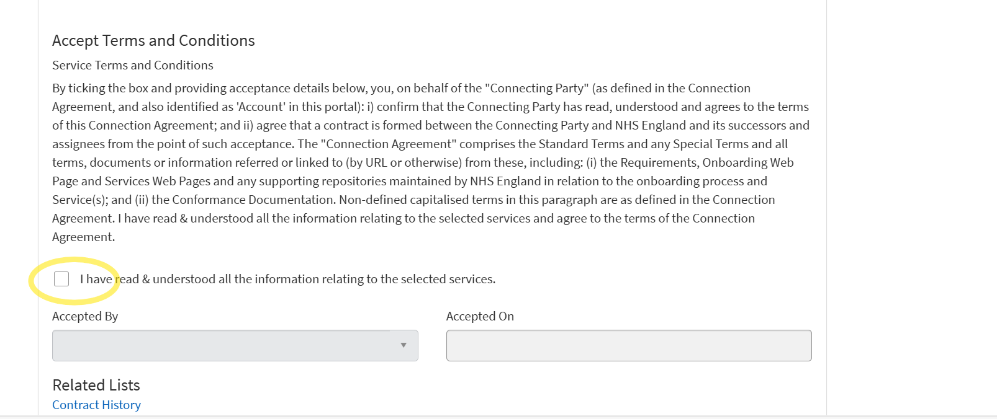
A case is created automatically when a new contract is created for “API Products Applicable”, which has signature type “Accepted via Portal”.
The case can be accessed via the customer portal. This is for communication between the connecting party and NHSE Connection Agreement/Contract creation team. The Connecting party can add notes or queries in the activity section.
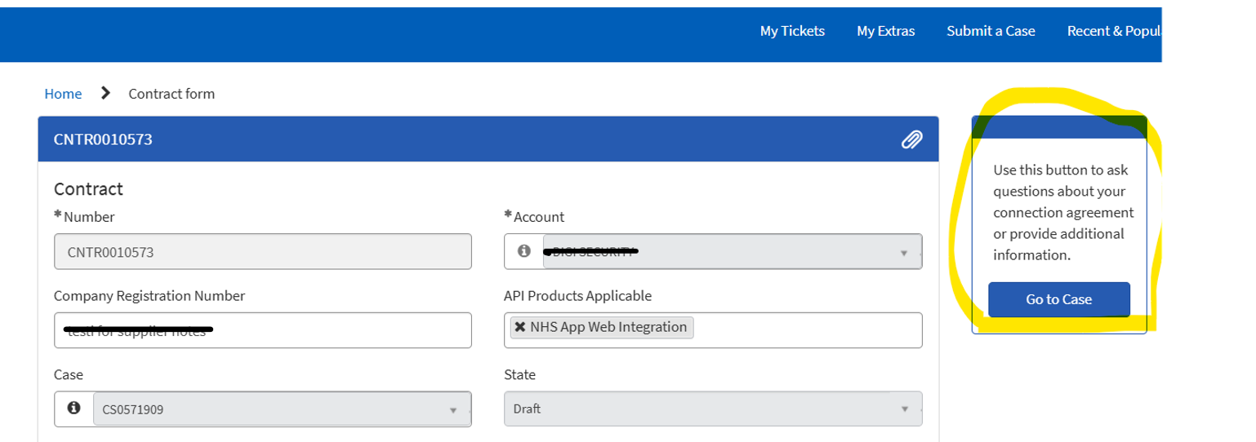
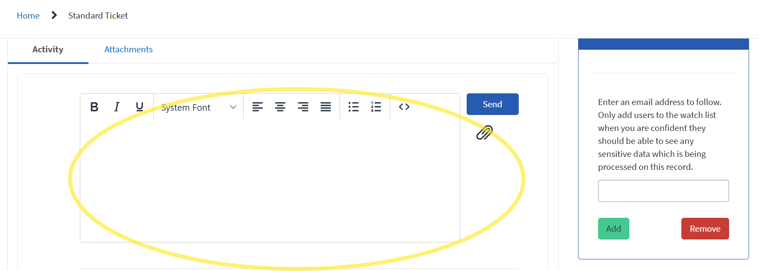

Updates to the terms and conditions following a policy/process review are set to auto accept after 30 days. This is a terms change, signature type is “Auto Accepted” There is no option to select the tick box to state you have read and understood. This process allows 30 days for review and the option to raise a query. If you have any questions regarding the changes in line with Clause 8.5 under Change Management of the Standard terms, please review the Connection Agreement Published found under Core documents as part of your review here; Operations - NHS England Digital
To open a case to query a terms change for signature type “Auto Accepted” where the original version is replaced with new contract number, select “Raise a query”
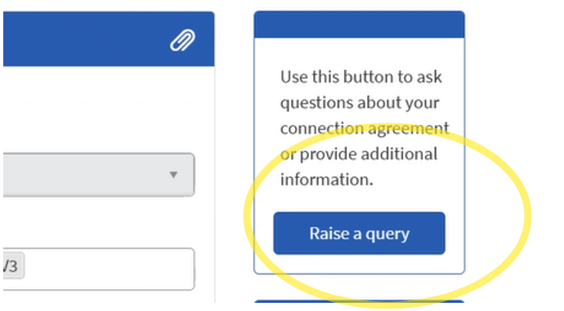

Enter your questions within the “Description” section and click “Submit”.
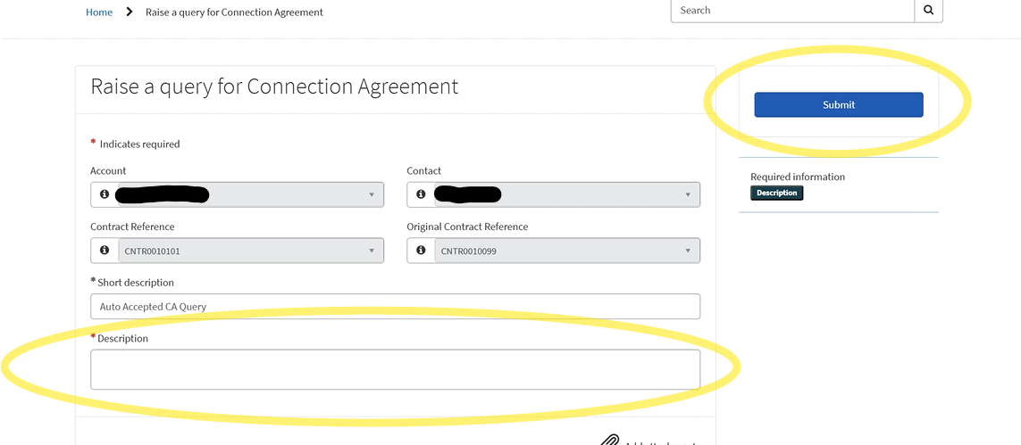A case is created, and your message will be sent to the NHS England Connection Agreement/Contract team via the case. All messages including responses from the NHS England Connection Agreement/Contract team will be displayed here.
You can also add additional email address to the “watch list”.
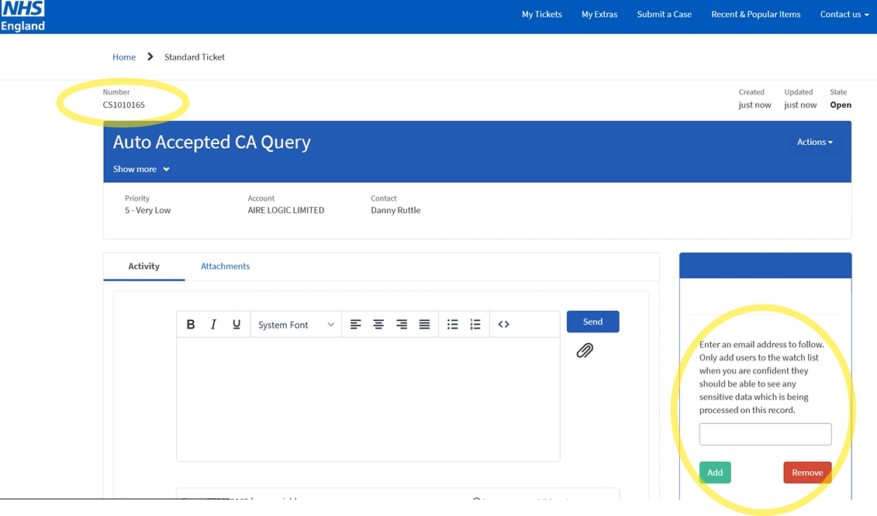

Download PDF version Connection Agreement/Contract for review
The Connection Agreement/Contract is a downloadable PDF document. Please screen shot below.
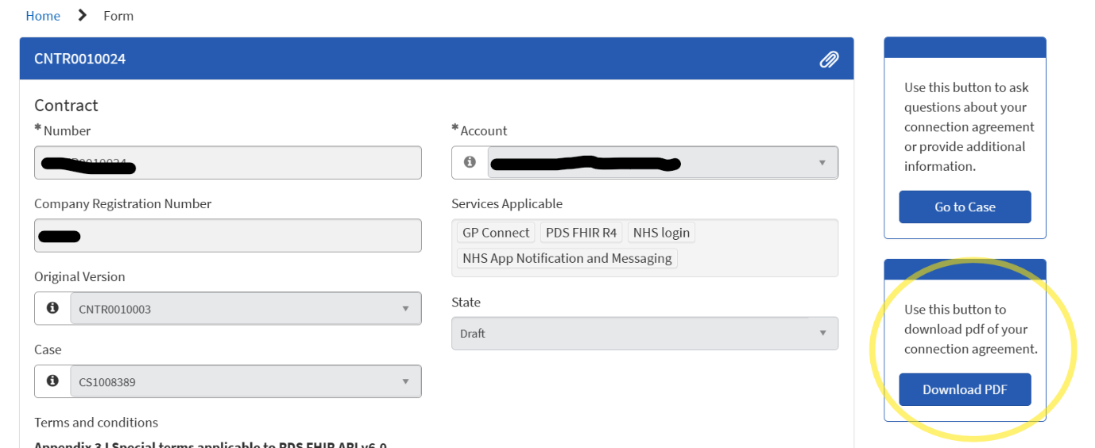The PDF download will show as attachment once the “Download PDF” button above has been selected.
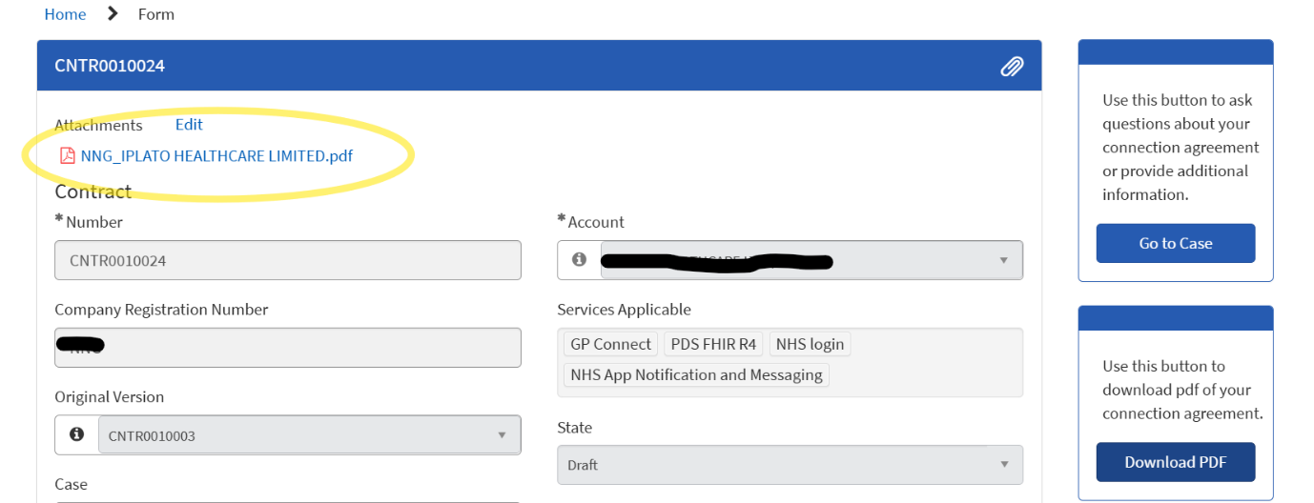

The below screenshot shows an example for PDF Download of a new contract with signature type “Accepted via Portal”.
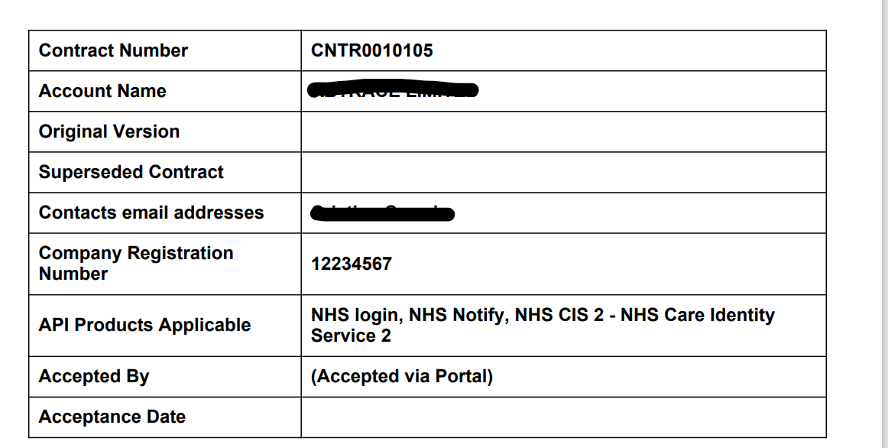

The following fields will be displayed on the PDF version of the Connection Agreement/Contract.
“Contacts email addresses” displays all recipients who have been notified to view the Connection Agreement/Contract. If they are registered as an onboarding contact within Service now under this account it will be displayed as full name, rather than email address. If a delivery notice email address has been provided to NHSE, the group email will display as full email address.
“Accepted By” will state “Accepted via Portal” for a Connection Agreement/Contract issued for a new contract “API Products Applicable”.
“Accepted By” will state “System Administrator (Auto Accepted)” when there has been a terms change.
“Original Version” this is the most recent version that was a new contact issued for acceptance of “API Products Applicable “containing signature type “Accepted via Portal”.
“Superseded Contract” this is the previous Connection Agreement/Contract to the new Connection Agreement/Contract.

Below is an example for PDF Download Connection Agreement/Contract for a terms change with Signature type “Auto Accepted”.
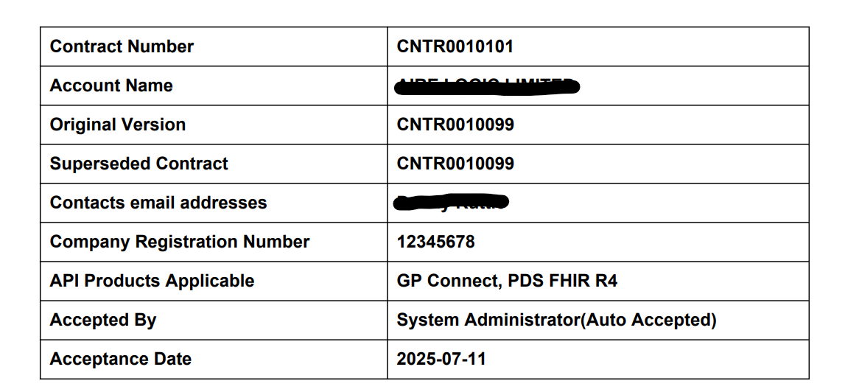
If you experience any issues or would like to provide feedback on this process, please contact england.liveserviceonboarding@nhs.net

