Private and confidential [LA_Name]
[LA_Address1] [LA_Address2]
[LA_Address3]
[LA_Postcode]
Tel: [LA_Telephone]
Email: [LA_Email]
Parent/Carer of «FirstName» «LastName»
«Address1»
«Address2»
«Address3»
«Address4»
«Address5»
«Postcode»

25 July 2025
NHS number «NHSNumber»

Dear parent/carer of «FirstName» «LastName»,

We recently wrote to you about measuring «FirstName»’s height and weight as part of the National Child Measurement Programme (NCMP). Here are «FirstName»’s measurements.
«FirstName»’s measurement data
Type of measurement | Measurement
Height (cm) | «Height»
Weight (kg) | «Weight»
Date of measurement | «DateOfMeasurement»

Your child’s measurements are confidential

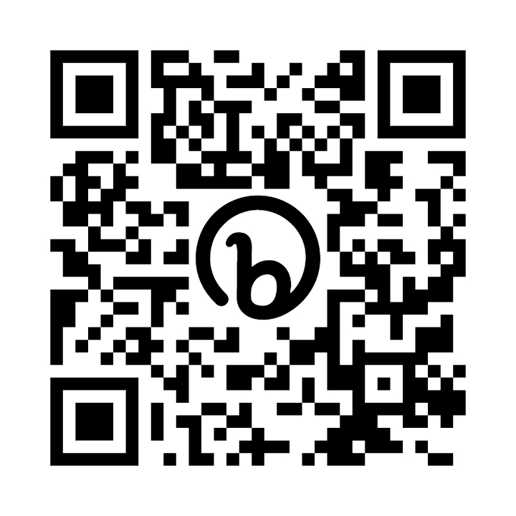

These measurements suggest that on the day they were measured, OBFirstName would be above the expected weight range for their age, sex and height.
You can find out how OBFirstName’s measurement was calculated and check how OBFirstName is growing over time, by going to the NHS ‘Calculate your body mass index (BMI)’ webpage. The information in this letter is private. It has not been shared with OBFirstName.It has also not been shared with other children or school staff. Your [local NHS or local authority public health team] keeps this information securely.
It is up to you, as their parent or guardian, to decide whether to share this information with your child .We recognise that talking about weight can be a difficult subject which is why OBFirstName’s measurements have only been communicated to you. These measurements only represent a one-off assessment of your child’s growth on the day they were measured.
A GP, school nurse, or other health professional can help you understand how this fits in with their growth, development and behaviour.
You may also consider measuring OBFirstName’s waist to height ratio by going to the NHS ‘Calculate your waist to height ratio’ webpage. This can help you understand the risk of any potential physical health conditions. The NHS ‘How to measure your waist’ video can guide you. Having a healthier weight can improve your child’s health and wellbeing. If you are not already doing so, being active and eating healthily can be good for the whole family. This can be hard for a lot of people, so there is help available. More information is available from the NHS Better Health ‘Children’s weight’ webpage.

What you can do now
Healthy growth, a healthy diet and being physically active are all important for children’s health and wellbeing.

Support your child to eat healthily and be physically active
OBFirstName has been reserved a place at the [local authority to insert name of local child and family weight management service].
This is a free and fun club to help children with their families achieve and maintain a healthy growth. See the enclosed leaflet or call [local authority to insert contact number for local family weight management service] or email [local authority to insert email address for local family weight management service].
[Delete lines above if there are no local child and family weight management services available]

Other sources of advice and information
Take a look at the NHS Better Health ‘Easy ways to eat well and move more’ website for healthy and easy recipe ideas.
Children need to be active for at least an hour every day. If you are doing this already, that’s brilliant. It is a good idea to mix moderate activity like brisk walking with vigorous activity like running or fast cycling. We have provided a leaflet on activities in your area [local authority] to include leaflet or remove this sentence] or visit the NHS Better Health ‘Activities for kids’ webpage.
Another way to help maintain a balanced diet and physical activity for your family is the NHS Healthy Steps email programme. Sign up for the 8-week Healthy Steps emails and you will be sent lots of low-cost easy tips, fun games, healthy swaps and tasty recipes on a budget.

Scan the QR code or visit ‘healthysteps.uk’ to sign up.
If you would like advice about talking to your child about weight, visit the University of Bath’s ‘Talking to your child about weight: a guide for parents and caregivers of children aged 4-11 years’ webpage to download the guide. Or if you would like to talk to someone about the NCMP and your child’s health and growth, please contact the NCMP team on [local authority to insert team and contact number].

Supporting your child to have healthy gums and teeth
Healthy gums and teeth are also part of a healthy lifestyle. Simple advice available at the NHS 'Children's teeth’ webpage will help your child have healthy gums and prevent tooth decay. For further information on looking after your child’s teeth, please visit the NHS ‘Sugar: the facts’ and 'Tooth decay’ webpages.
Kind regards,
[Sender name and job title]

