Auditing local CP-IS usage

Version 1.01 – February 2024

Document Management
Revision History
Version | Date | Summary of Changes
0.1 | 20/05/2018 | Initial draft
1.0 | 25/10/2018 | Final version
1.1 | 02/02/2024 | Updates from SCR to NCRS

Reviewers
This document has been sent to for review and/or reviewed by the following people (please include nil returns):
Reviewer Name | Title / Role / Directorate | Version | Date Sent to Reviewer | Date Feedback Received | Feedback Actioned (Y/N?)
Mark Weston | IBC | 0.1 | 23/10/18 | 23/10/18 | Y
Alex Clifford | CP-IS Service Manager | 1.1 | 02/02/2024

Approved by
This document has been approved by the following people:
Name | Signature | Title | Date | Version
Rahial Kazmi |  | Senior IBC Manager

Document Control:
The controlled copy of this document is maintained in the NHS Digital corporate network. Any copies of this document held outside of that area, in whatever format (e.g. paper, email attachment), are considered to have passed out of control and should be checked for currency and validity.

Contents
- Introduction
- Accessing User Reports
- Viewing/Running Reports

- Introduction
This document is designed to assist local organisations who use NCRS to access Child Protection Information Sharing (CP-IS) data, to review and audit their local usage (if using an integrated solution then alternatively consult your clinical systems supplier). Organisations may wish to do this to check that local CP-IS business processes are working effectively. The need is to ensure CP-IS is being routinely accessed by staff with CP-IS permissions e.g. To review whether a patient’s record has been requested and accessed appropriately upon presentation at the unscheduled health setting.
To access the functionality on the Spine Reporting Service, one of the following Smartcard job roles is required:
- Privacy officer, Job Role Code - R0001
- Caldicott Guardian, Job Role Code - R5105
In addition, the user will also need the smartcard RBAC activities
- B0264 – Access NCRS (perform patient trace)
- B0107 – View Child Protection Plan
A list of key reports that the Spine Reporting Service can produce are:
- Patient Access Report - The purpose of this report is to see which end users have accessed the specified patient during the period entered.
- User Access Report - The purpose of this report is to identify the NCRS transactions for a specified end user during the period entered
- Patient Enquiries Report - The purpose of this report shows the specified date range which end users have traced patients within NCRS, the NHS Numbers on which they have performed a trace and how many enquiries they have made for each patient listed within an organisation
The maximum search period for each report is one month, however data can be exported and compiled for multiple months.
You can access the portal using the following links:
National Health Service Spine Portal Web Link: https://portal.national.ncrs.nhs.uk
Spine Reporting Service: Spine Reporting Service (SRS)

2. Accessing User Reports
To access any of these reports:
- Insert a valid smart card (with the required smartcard permissions as outlined in section 1)
- Open the NHS Spine Portal - https://portal.national.ncrs.nhs.uk
- Select ‘Spine Reporting Service’ from the main menu

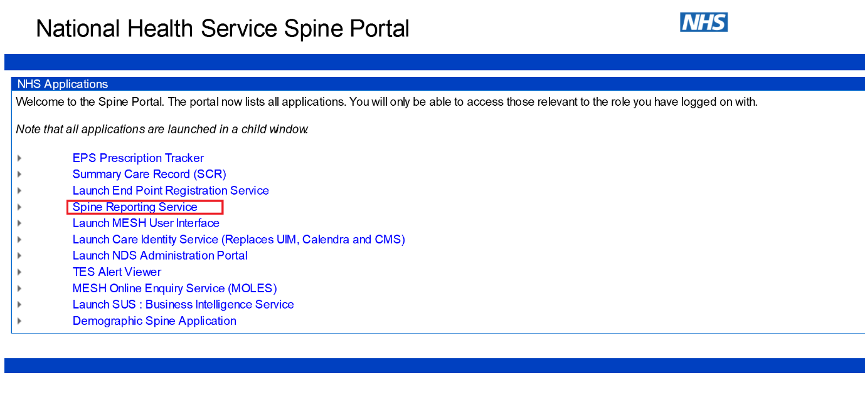
Within the Spine Reporting Service, you can access, view and run User Reports as follows:
E.g.
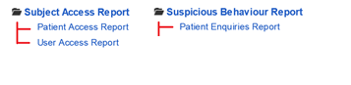
These reports allow the user to view different details of information.
The rest of the guide will explain how to view/run and interpret these three reports.

3. Viewing/Running Reports

- Patient Access Report
- A report showing which end users have accessed the specified patient during the period entered.

To access this report:
- Select ‘Spine Reporting Service’ from the Spine Portal main menu (home screen).
- A new window will open with submenu on the left (depending on your role profile) 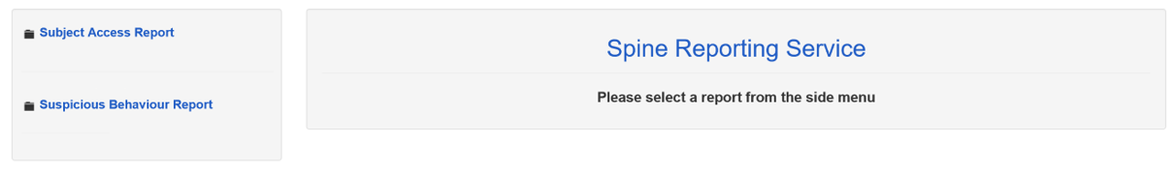
- Select Subject Access Report – this will expand to show you Patient Access and User Access Report 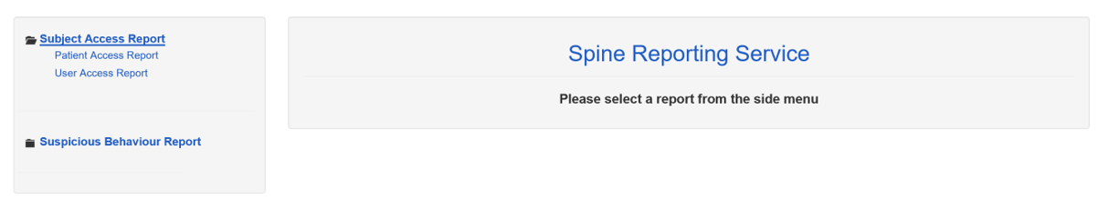
- Select Patient Access Report
- A new window will open
- Enter the Start date in the Start date field.
- Enter the End date in the End date field. (The start and end date will be the date range for the report).
- Enter the Patient NHS Number in the Patient NHS Number field. (This is the patient that you would like to query)

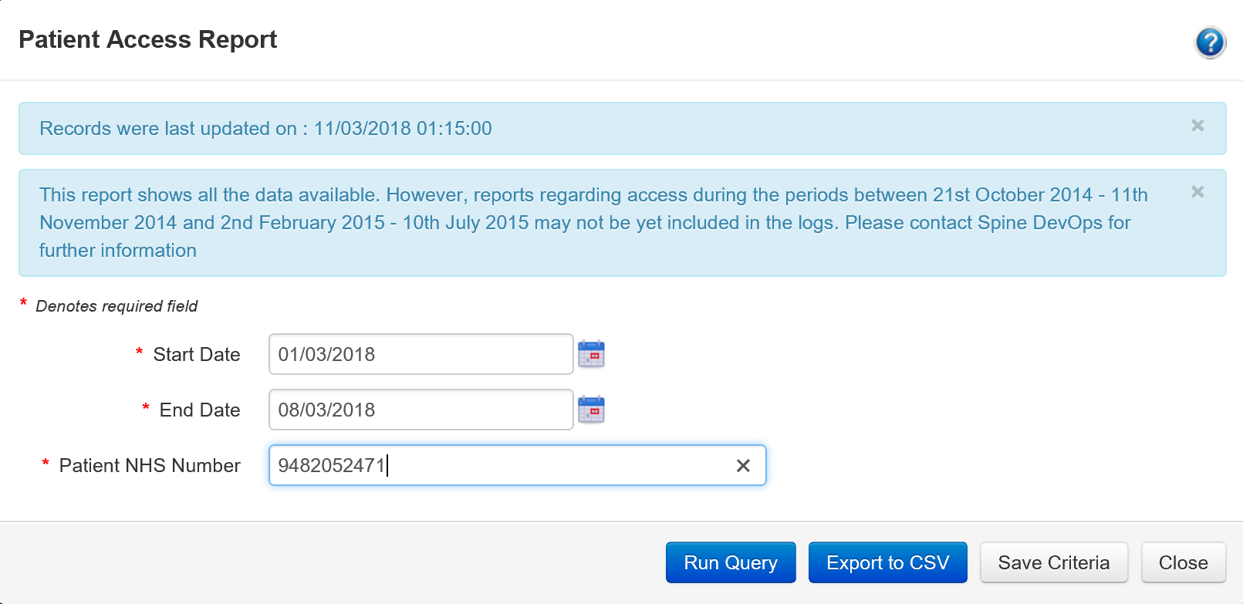
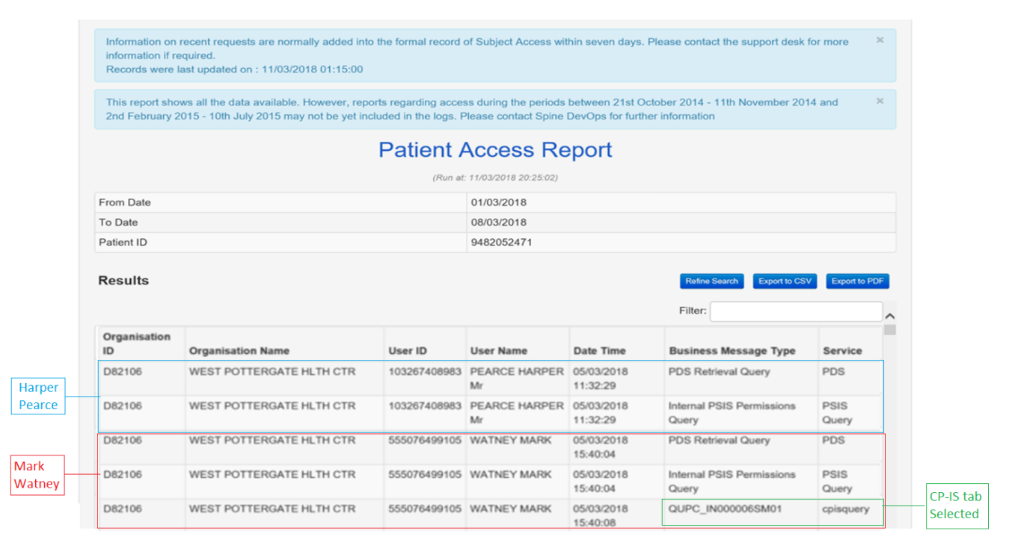
- Select the ‘Run Query’. This will open a new window returning any information for NHS Number within the selected date range.

Narrative:
Harper Pearce carried out a Personal Demographics Service (PDS) trace but did not click the CP-IS tab.
Mark Watney carried out a PDS trace and clicked the CP-IS tab.
The illustration above shows that two users searched for the specified patient. Harper Pearce and Mark Watney. Both users from the same organisation.
Harper Pearce viewed the patients PDS only but did not click the CP-IS tab. This means only the PDS Retrieval and Internal PSIS Permissions query was generated in NCRS.
Mark Watney viewed the patient and this time selected the CP-IS tab. This means the same PDS retrieval and Internal PSIS (Personal Spine Information Service) Permissions query was generated however an additional CPIS Query (QUPC_IN000006SM01) is now included as the CP-IS tab was selected.
The inclusion of the CP-IS Query is the main difference to indicate which user has looked at a patient and which user has looked and clicked the CP-IS tab of a patient.
Note: By clicking on the CP-IS tab the user will see the CP-IS dataset (Type of plan, Start date, End date Responsible local authority, contact details for the LA) and the 25 previous access events.
The report generated will show the user all the NCRS transactions associated with all users at the Privacy Officer’s Organisation within a date range for a specific patient.
To change the date range – press the refine search button. This will allow you to enter a new date range.
The report can be exported to excel etc by selecting the ‘Export to CSV’ button’
Report Key:

Organisation ID: ID of the organisation the NCRS user belongs to
Organisation Name: Name of the NCRS Users Organisation
User ID: UUID of the smartcard belonging to the NCRS user
User Name: Name of the NCRS user
Date Time: Time and date when the transaction took place
Business Message Type: The type of NCRS transaction
Service: The Spine service that the transaction relates to

- User Access Report
- A report identifying the NCRS transactions for a specified end user during the period entered

To access this report:

- Select ‘Spine Reporting Service’ from the Spine Portal main menu (home screen).
- A new window will open with submenu on the left depending on your role profile
- Select Subject Access Report – this will expand to show you Patient Access and User Access Report
- Select User Access Report
- A new window will open
- Enter the Start date in the Start date field.
- Enter the End date in the End date field. (The start and end date will be the date range for the report).
- Click in the User UUID field.
- This will expand to provide more search options. Enter the surname name or part of the name of the user in your organisation that you are searching for in the field next to the magnifying glass.
- Click the magnifying glass button.
- Returned user names will appear in the box above. Select the correct user (if there is more than one name returned). 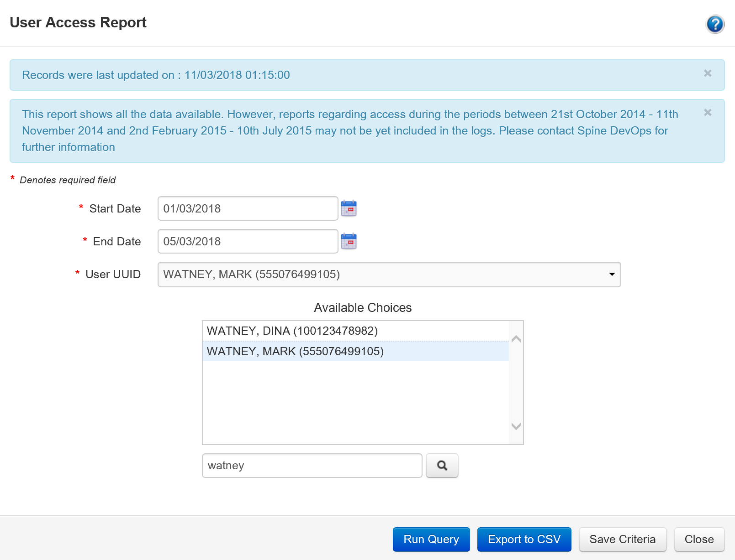
- Select the ‘Run Query’. This will open a new window returning any information for User Access within the selected date range.

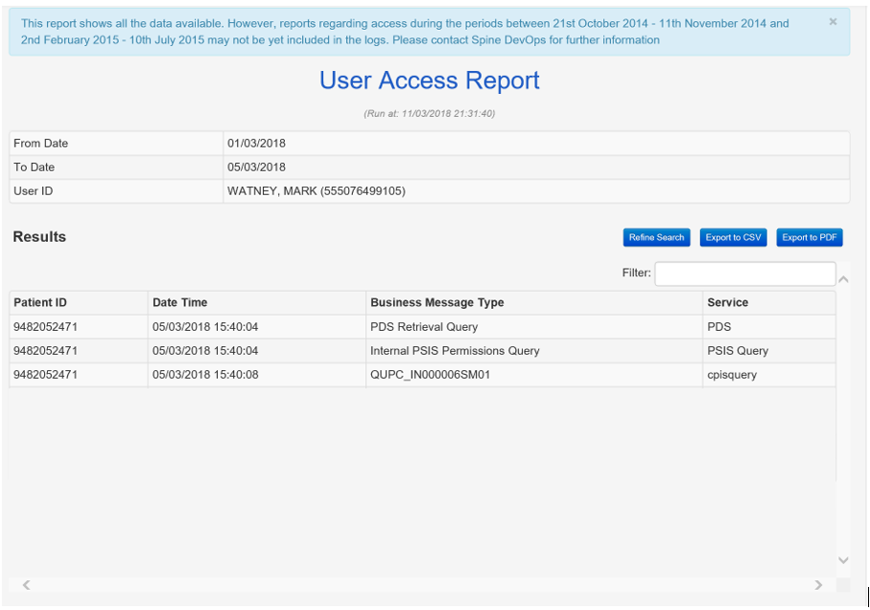
The illustration above shows all the activities carried out by Mark Watney within a specific date range. This report shows the time and date a patient was viewed and if the CP-IS tab was clicked.
To change the date range – press the refine search button. This will allow you to end a new date range.
The report can be exported to excel etc by selecting the ‘Export to CSV’ button.

Report Key:

Patient ID: NHS Number of the Patient searched for by user in NCRS
Date Time: Time and date when the transaction took place
Business Message Type: The type of NCRS transaction
Service: The Spine service that the transaction relates to.

- Patient Enquiries Report
- A report showing the specified date range which end users have traced patients within NCRS, the NHS Numbers on which they have performed a trace and how many enquiries they have made for each patient listed within an organisation

To access this report:

- Select ‘Spine Reporting Service’ from the Spine Portal main menu (home screen).
- A new window will open with submenu on the left (depending on your role profile)
- Select Suspicious Behaviour Report – this will expand to show you Patient Enquiries Report, User Enquiries Report and User Activities Report 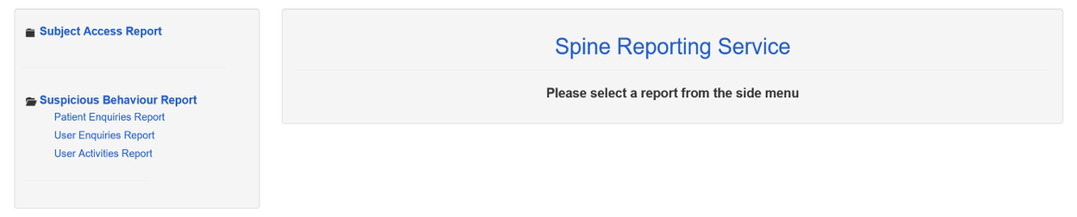
- Select Patient Enquiries Report
- A new window will open
- Enter the Start date in the Start date field.
- Enter the End date in the End date field. (Note: The end date cannot be more than 31 days after the start date. The maximum search period for each report is one month, however data can be exported and compiled for multiple months.)
- Click in the Organisation field.
- This will expand to provide more search options. Enter the name or part of the name of the organisation that you are searching for in the field next to the magnifying glass.
- Click the magnifying glass
- Returned organisation names will appear in the box above. Select the correct organisation (if there is more than one name returned).
- Change the value to 1 in the ‘Excessive Enquiries on a Patient Threshold’ field. (Note: Entering 1 will display patients where 1 or more enquiries have been made against a patient. Entering a different value will change the threshold as required).
- Using the drop-down button in the ‘Include out of hours’ field select if you would like to include the out of hours by choosing yes or no. 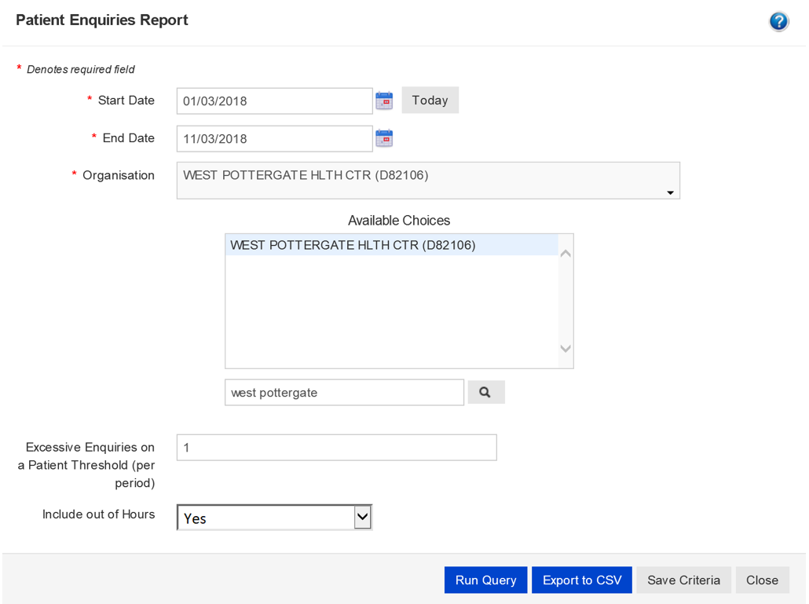
- Select the ‘Run Query’. This will open a new window returning any Patient Enquiry information within the selected date range.
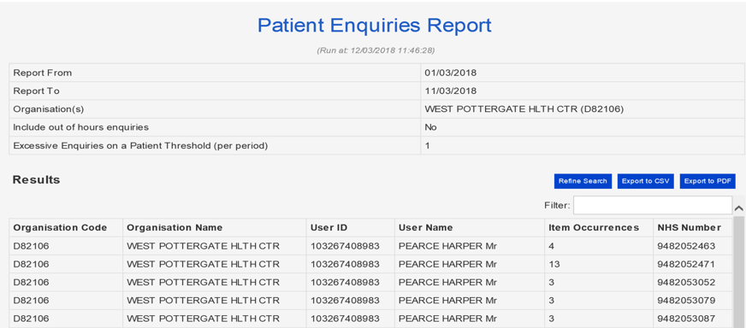

The report generated will show a list of all the users who at the organisation specified traced the patient’s listed and the number of enquiries per patient made within a selected date range.
To change the date range – press the refine search button. This will allow you to end a new date range.
The report can be exported to excel etc by selecting the ‘Export to CSV’ button.

Report Key:

Organisation Code: Name of the NCRS Users Organisation Code
Organisation Name: Name of the NCRS Users Organisation
User ID: UUID of the smartcard belonging to the NCRS user
User Name: Name of the NCRS user
Item Occurrences: List the number of times a patient was searched for
NHS Number: The NHS Number of patient searched

