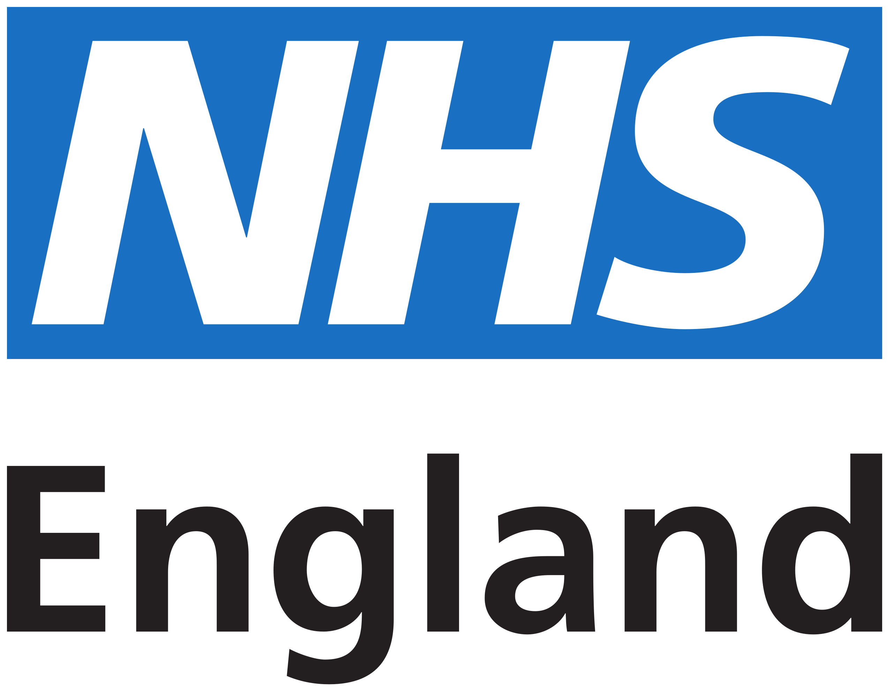
Your Registration Authority / smartcard contact

If you have problems with your smartcard you can contact your Registration Authority.
Contact name:
Contact details:

Your new smartcard
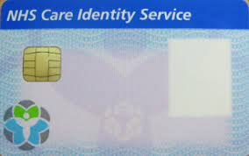

Your smartcard will be personalised with your name, photograph and UUID (Unique User Identification) number.

Using your smartcard
How you log in with a smartcard and access patient information can differ by organisation. In general you will:
- place your smartcard in the reader attached to the PC or laptop that has access to the NHS Spine
- enter the passcode you chose or were given when you first got your smartcard
- access the services you need

If your smartcard is locked
If you have an email address associated with your Care Identity profile, you can unlock your smartcard at https://digital.nhs.uk/unlock

If you do not have an email address associated with your profile, you’ll need to contact your Registration Authority to unlock your smartcard.

If you've forgotten your passcode
If you have an email address associated with your Care Identity profile, you can reset your passcode at https://digital.nhs.uk/unlock

You can also use the same URL to change your passcode for any reason.

If you do not have an email address associated with your profile, you’ll need to contact your Registration Authority to reset your passcode.

Renewing your smartcard
Smartcard certificates are valid for 3 years. If your certificates are going to expire in the next 90 days you will get a smartcard expiry alert each time you log in, until you renew them.
You can read instructions on how to renew your smartcard certificates at https://digital.nhs.uk/services/care-identity-service/smartcard-and-authentication-users/self-renewal-nhs-smartcard-service

If your smartcard is lost or stolen
You must contact your Registration Authority immediately. They will cancel your card and replace it.

If you're leaving the organisation
If you're moving to a different organisation within the NHS, take your card with you to use in your next role.
If you're leaving the NHS, return your smartcard to your line manager. If you rejoin the NHS in the future your profile will be reactivated and you'll be issued with a new smartcard.

