

Data Landing Portal (DLP)
Non-NHS User Registration &
Access Request Guide

Contents

- What is changing?
- What does this mean for you as a registered IF-DLP user?
- Who should register for DLP via NHS England Applications?
- What is NHS England Applications?
- Registering for an NHS England Applications account
- Account Activation
- Password Reset
- Account Unlock
- Need more help?
- Signing-In and Navigating the NHS England Applications
  - How to update Organisation Code in NHS E Apps?
- Requesting access to DLP
- Access Approved
- Accessing DLP
- Sign-In to DLP with NHS E Apps Credentials

What is changing?

As of January 31, 2024, IF-DLP (Data Landing Portal) Registration and IF-DLP Authentication have been deprecated. Starting from October 1, 2024, registration and authentication for non-NHS users* will be transitioned from Care Identity Service authentication (CIS1) to NHS England Applications.

* A non-NHS user in this context is someone who does not possess a smartcard and does not have access to a Registration Authority (RA) to set up a Care Identity. These users cannot use CIS2 authentication to access the DLP. Non-NHS users typically have a non-NHS domain email address.

What does this mean for you as a registered IF-DLP user?

- From 1 October, no new users will be registered via IF-DLP Registration.
- The support for the IF-DLP Authentication service (email and OTP) will be phased out after November 1, 2024.
- Going forward all IF-DLP and DLP users will access the Data Landing Portal (DLP) via (https://dsp-portal.national.nhs.uk) and must authenticate using either Care Identity Authentication (CIS2 Auth) or NHS England Applications.
- Please review the authentication method you need to use and complete the necessary changes before November 1, 2024, to ensure uninterrupted access to DLP.

Who should register for DLP via NHS England Applications?

If you are a registered IF-DLP user with an email address ending in nhs.net or nhs.uk, you should verify whether you can access DLP using a Care Identity:

- If you have a Care Identity but it is inactive, contact your Registration Authority (RA) to re-register.
- If you have an active Care Identity, contact your RA to request the appropriate role for use with the Data Landing Portal.
- If you do not have a Care Identity profile, but your organisation has an RA, contact your RA to be set up using the Apply for Care ID service.

If you are unsure whether your organisation has an RA, refer to the "Find Your Registration Authority" tool.

It is strongly preferred for users to access DLP using a Care Identity. However, if you are unable to use a Care Identity to access DLP, you should register for access via NHS England Applications as below.

What is NHS England Applications?

NHS England Applications provides a range of analytical and digital products and uses OKTA as an identity management service. It acts as a central access point to many of our existing business tools and applications, developed by NHS England.

If you are NHS staff or support provider trusts, Commissioners, or systems across the NHS, register or log to discover the range of improvement products and services available. Once your access is approved, you can browse by category and choose from a broad list of topics.

Registering for an NHS England Applications account

To access and use business tools and applications via the NHS England Applications you will need:

- An NHS England Applications account with associated OKTA login credentials.
- Authorized access to the required application provided by the product team
You will have to register for an NHS England Applications account. Open this link in your Chrome or Edge browser: https://apps.model.nhs.uk/register .
The Registration screen will be displayed. Complete the fields as requested.

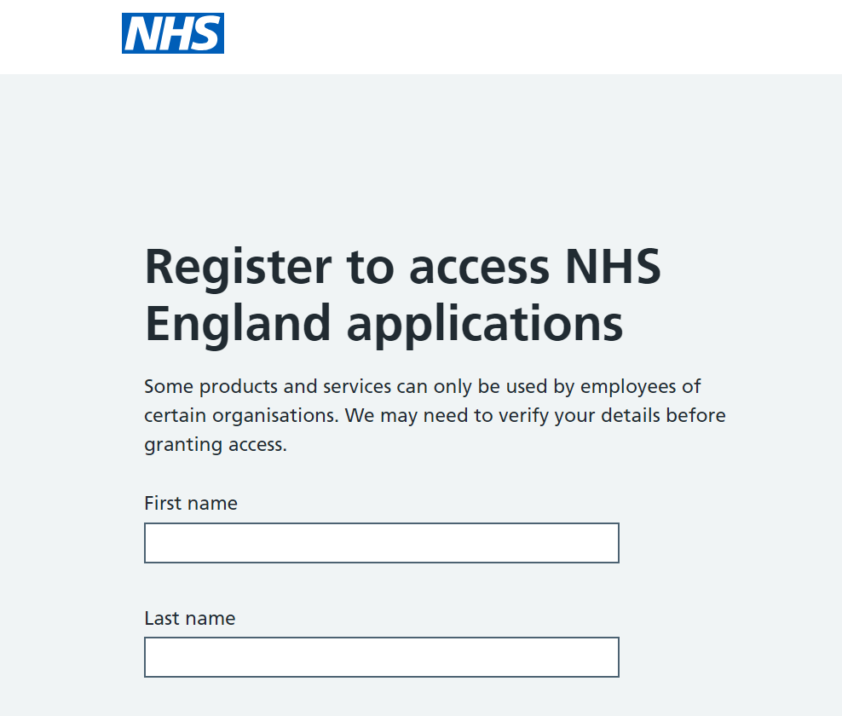

Scroll down and enter your work email address, making sure to use your individual email rather than a group email. Use the drop-down menus to select both your job role and the organisation you work for. Depending on your chosen organisation, you may be asked to select a region or a specific trust.

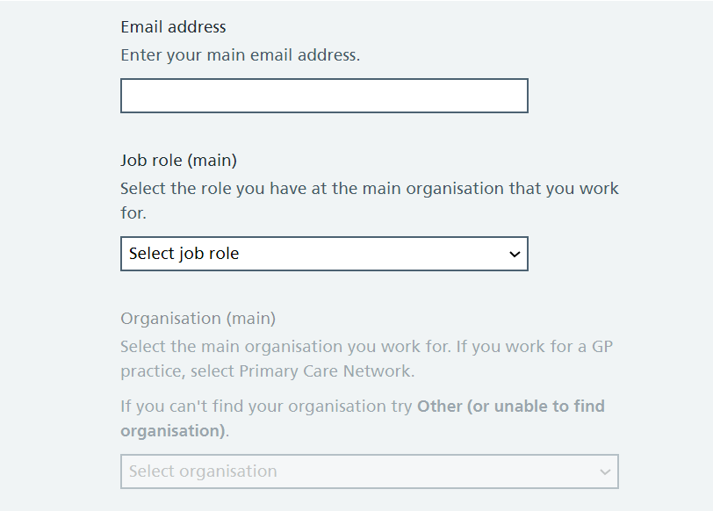

- If your organisation is set up on DLP but not yet available on NHS E Apps, please be patient, we are in the process of setting up these missing organisations and expect to complete this by 18th October 2024. If your organisation is still missing after this date, contact the National Service Desk for assistance at ssd.nationalservicedesk@nhs.net.

- If you cannot find your organisation, select "Other" (or "Unable to find organisation"). If your organisation is not listed under "Other," it indicates that your organisation needs to be set up for DLP.

- Please complete the DLP Data Sender Registration form available at https://digital.nhs.uk/services/data-landing-portal and send it to ssd.nationalservicedesk@nhs.net for setup.

- After submitting the form, you will receive an email from the DLP service team once the setup is complete. This email is typically sent within a week, but it may take up to 28 days.

- Once the organisation setup is finished, you can return to this step and register using NHS E Apps.
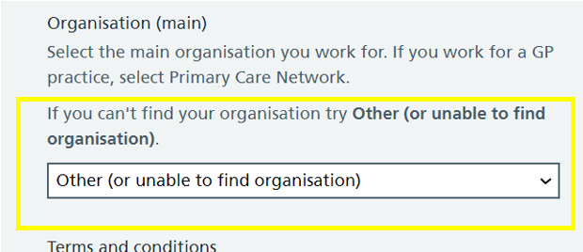

If you are associated with an additional organisation, region, or trust and wish to submit data for each of these organisation’s on DLP, please note that we currently do not have the functionality in NHS E Apps to add multiple organisation’s to a single user profile. We are working on an alternative solution and plan to release it on or before October 31st. In the meantime, please continue using the IF-DLP e-mail and OTP method for additional organisations.

After completing all the fields, click the tick box to agree to the terms & conditions required to use this platform and Click Register.

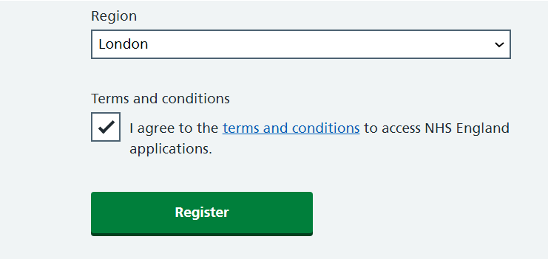

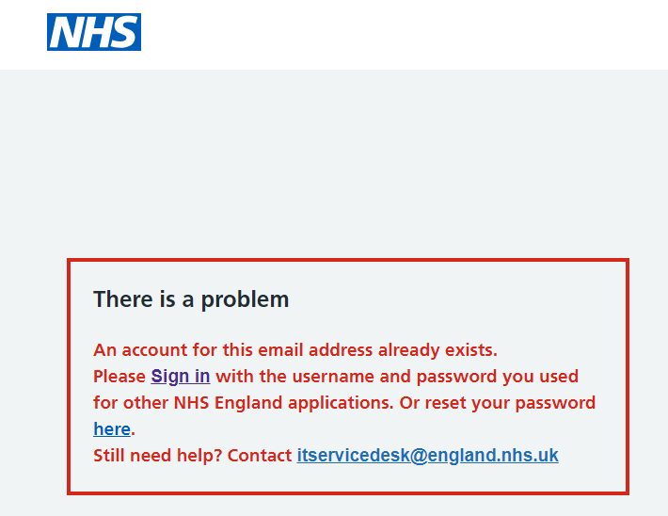
NOTE: If an account for the email address you have entered already exists an error will be highlighted in red with a detailed description of the problem and how to resolve it.

You will now see a notification confirming that you have completed this part of the registration process, and you will also receive an email notification from the apps@model.nhs.uk team.
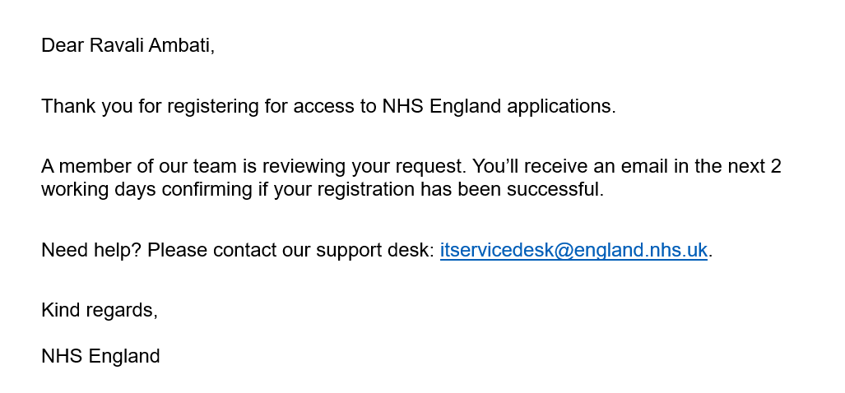

If you do not receive confirmation regarding your registration from the NHS E Apps team within two working days, please contact: itservicedesk@england.nhs.uk.

Account Activation

- You will receive email confirmation from apps@model.nhs.uk with the subject: Activate your access to NHS England applications. You will need this email to complete the registration process.

- Click the Activate my account link. Here you will need to create a password and set your security question. When complete, click Complete Registration. You will now see a message confirming that your registration is complete.

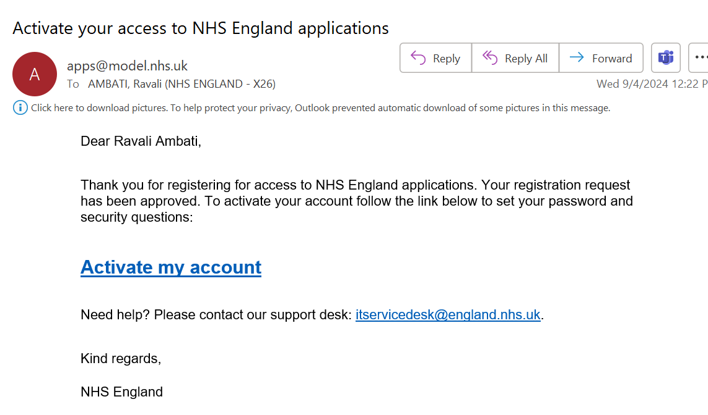

Important Note: You should use the credentials you set up on NHS E Apps to sign in to DLP.

Sign-In

You can now Log in to NHS England Applications .

Enter the credentials that you just set up.

Click Sign In.

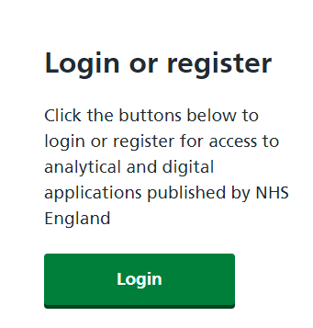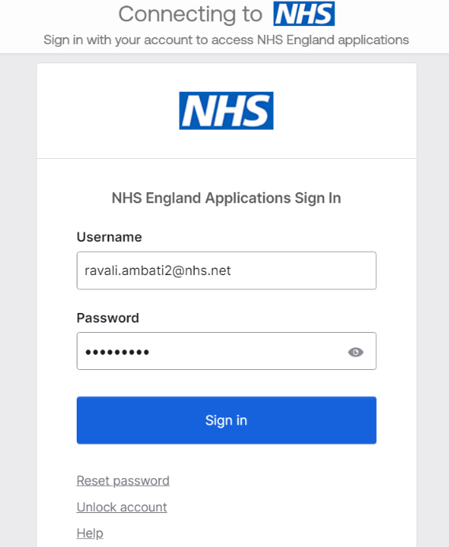

Password Reset

If you have forgotten your password, click Reset Password on the Sign In page or click here. To complete the password reset, click on verification link in the email. Please note that a verification code is not included in the password reset email as mentioned above, so you can disregard that part.

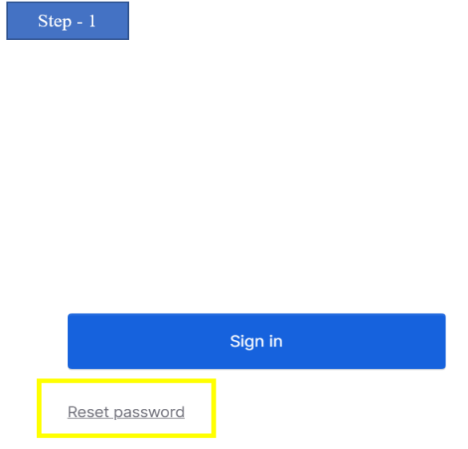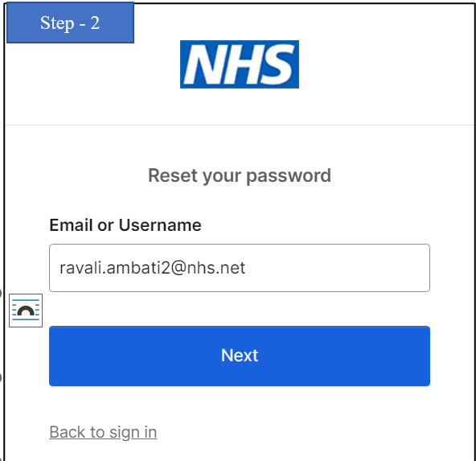

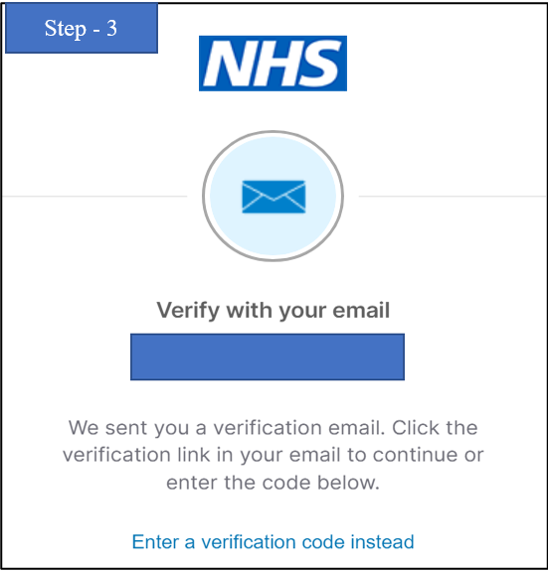

Account Unlock

If you have locked your account, click on Unlock account on Sign In page or click here.

Enter your username and verify it's you with a security method.

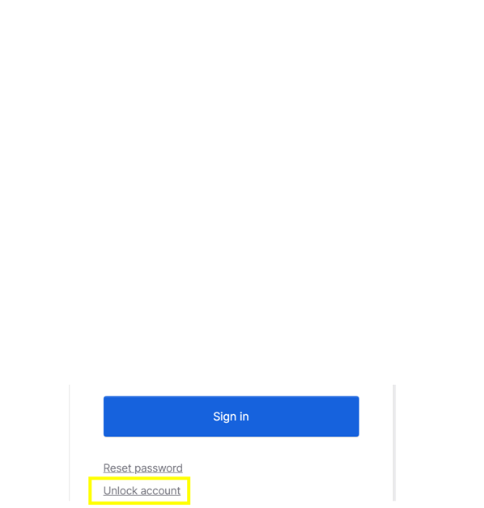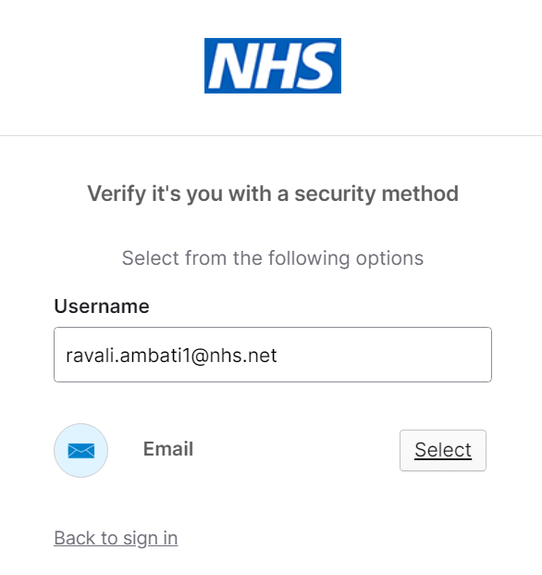

Need more help?

If you need any other help with signing-in or with your account, click on Help or please contact the support desk: itservicedesk@england.nhs.uk.

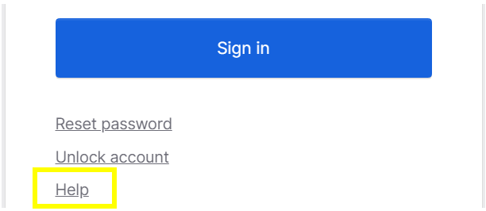

Signing-In and Navigating NHS England Applications

Now that you have an NHS England Applications account, you can request access to DLP. Click this link to access the Sign-In screen: https://apps.model.nhs.uk

Enter your credentials and click Sign-In.

The NHS England Applications homepage will now be displayed, allowing access to the tools and applications you are authorized to use. Your profile is also displayed at the top right of the screen providing options via the drop-down menu to manage/ edit your account and sign out of the portal.

There are two tabs displayed on this page – the A-Z index and My favourites.

- The A-Z index tab displays all the applications and services you have or can request access to

- The Favourites tab displays those applications you have added to your favourites for ease of access based on your consistent and regular use

- You can search for the Data Landing Portal or any other application by Application name

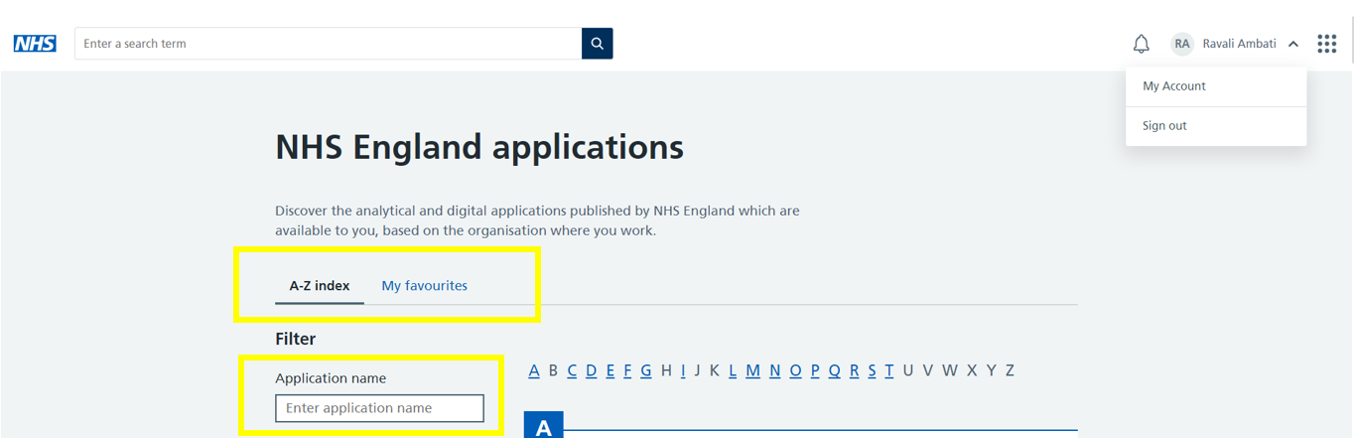

How to update Organisation Code in NHS E Apps?

- On the NHS England Applications homepage, click My Account. A screen with your current personal details will appear.

- Click Change to update your information.

- You’ll be taken to a page where you can update your name, job role, organisation, and region. Once you have updated the details, click Submit.

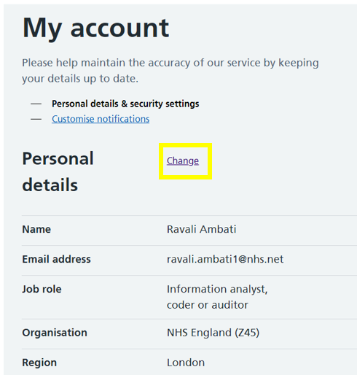

Important Note: If you change your organization code, the system will automatically submit an access request for the applications you previously had access to after assigning you to the new ODS code. This request will require administrator approval before you can regain access to the application.

Requesting access to DLP

- To request access, scroll down the homepage or search for "DLP" in the application name field, click Request Access

- A new screen will appear with the question: “Why do you need access to the Data Landing Portal…?” In the free text field, enter your reasoning in this format: "I need DLP access to send <data collection name> to <DSCRO name> or for national collection." Once you've entered your reasoning, click Request access.

- After submitting your access request for DLP your account should be approved within 2 working days

- Please contact your Data Services for Commissioners Regional Offices (DSCRO) to have it reviewed if you are unable to access DLP after this time. Your DSCRO is typically the organisation that asked you to submit the collection. If you don’t know who your DSCRO is, please contact dianeclark2@nhs.net

*Please note that some of the following screenshots are from the UAT environment and have "UAT" mentioned in their name. This will not be the case in the Production environment.

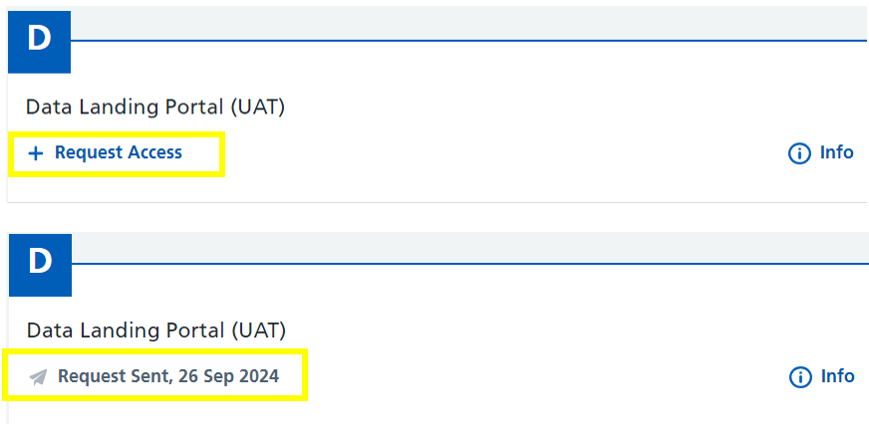

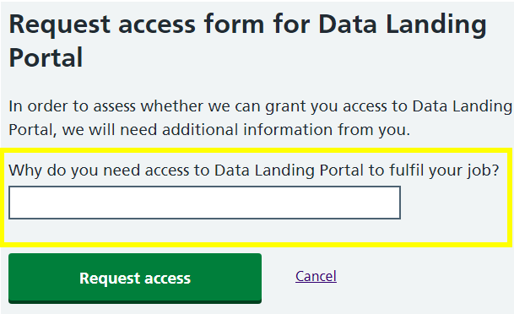

Access Approved

Once your access has been approved you will be notified by email.

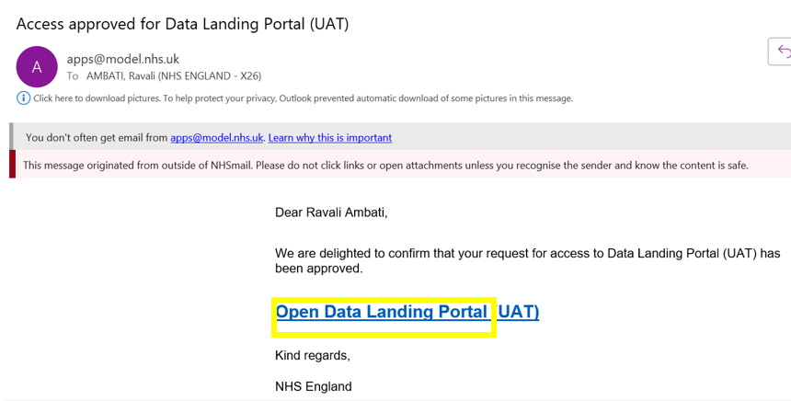

Accessing DLP

After your access is approved, you can click on Data Landing Portal in NHS E Apps or go directly to the application homepage via this link: https://dsp-portal.national.nhs.uk to access DLP. To add the product to your favourites, simply click the star icon.

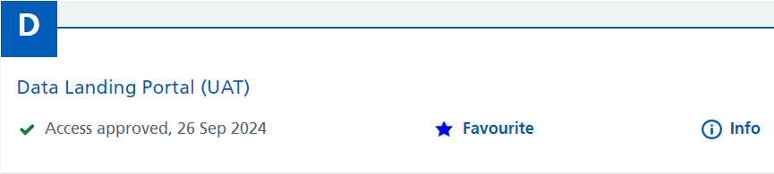

Important Note: Once you have completed the initial registration and gained access to DLP, there’s no need to log in to NHS E Apps each time you want to use it. You can simply use the direct link: https://dsp-portal.national.nhs.uk

Sign-In to DLP with NHS E Apps Credentials

On the DLP login page, click Log in as a third-party user.

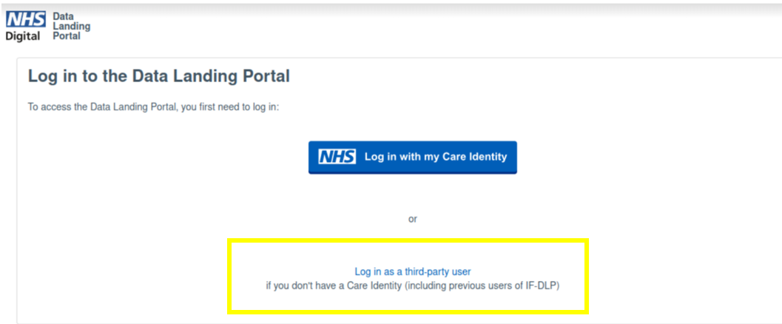

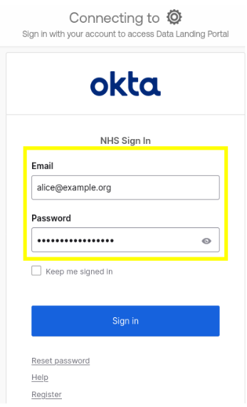
After this, the Okta NHS Sign-In screen will appear. Enter the credentials used to set up your NHS E Apps account.

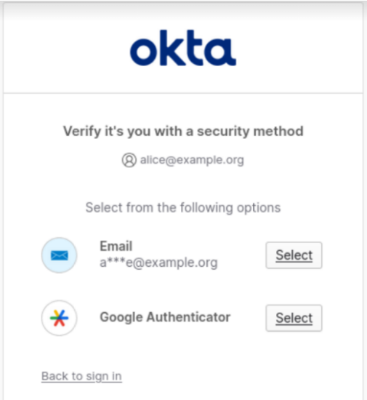
Authenticate your account using one of the methods presented.

Once logged in, the DLP Homepage will be displayed, allowing you to submit data. If you need to set up new file specifications, please contact your relevant DSCRO.

