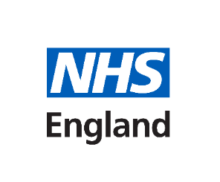
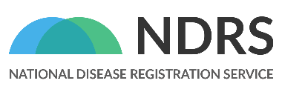
Standard wording for patient charities’ website privacy notice / email:
© 2026 National Disease Registration Service (NDRS). All Rights Reserved

National Congenital Anomaly and Rare Disease Registration Service (NCARDRS)
The National Disease Registration Service (NDRS) is part of NHS England and collects patient data on rare diseases, congenital anomalies and cancer in England. The NDRS provide expert timely analysis to support clinical teams, academics, charities and policy makers to help plan and improve treatments and healthcare in England. Within the NDRS, the National Congenital Anomaly and Rare Disease Registration Service (NCARDRS) collects and analyses data on people with congenital anomalies and rare diseases who live or are being treated in England.

The [INSERT NAME OF THE PATIENT CHARITY] have been working with the NDRS since [INSERT YEAR]. For rare diseases like [INSERT NAME OF RELEVANT RARE DISEASE], the NDRS collects a small amount of information about each person and their diagnosis. This can then be linked to other datasets, like those that capture prescribing and hospital activity.

To make sure that the national registration data is as complete as possible for each rare disease, the NDRS collects data from many data sources. Information from patient support group membership databases, like that provided by the [INSERT NAME OF THE PATIENT CHARITY], can play an important role in giving people the chance to make sure that the NDRS is identifying them.

When people sign up to become a member of the [INSERT NAME OF THE PATIENT CHARITY], they can also choose to have their data shared with the NDRS to form part of the NCARDRS register, if they live in or are being treated in England.

By sharing our data with the NDRS we aim to better understand [INSERT NAME OF RELEVANT RARE DISEASE]. The data can help clinicians, researchers and charities to provide better support for those living with the condition. The NCARDRS register is also used for research and planning by helping to:
- look at numbers and trends of people diagnosed with congenital anomalies and rare diseases
- improve health, care and services for people with these conditions
- support patients by providing information about their condition
- give the NHS information to help it further improve the services it provides.

There are strict controls on who can see the information held by the NDRS to protect your confidentiality. There are restrictions on how data is shared by the NDRS. You can find out more about how the NDRS keeps your data safe in the NDRS patient information leaflet.

If you would like to find out more about the NDRS and how they process personal data, visit the NDRS website.

