Step 3: Add Patient Record
In order to create a new patient record, click on ‘Add/Search for Patient Record’ at the top of the screen.
The ‘Add / Search for Patient Record’
screen is displayed.
Enter the NHS Number and the Date
of Birth of the patient. Click ‘Submit’.
The ‘Patient Information’ screen will be
displayed.
Note: If the patient already exists in the OAPs database, the patient’s record tree will be displayed. See ‘Step 6’ for details.

Before you start
Submitting data to the Out of Area Placements (OAPs) Collection is done via the Clinical Audit Platform (CAP); a secure, web based platform supported and hosted by NHS Digital.
In order to submit data to the collection, you must first register by creating an NHS Digital Single Sign On (SSO) account and submitting the OAPs User Registration Form.
Please refer to the OAPs website for further information.

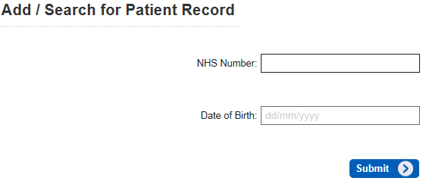

Step 1: Log into your NHS Digital Account
In order to access the Clinical Audit Platform and submit data, you must start by signing into your SSO account.
Enter your Username (your registered email
address), your password and click ‘Sign in’.

The email address used for SSO must be
the same as the one submitted on the User
Registration Form. If these email addresses
are not the same, you will not be able to
access the Clinical Audit Platform.

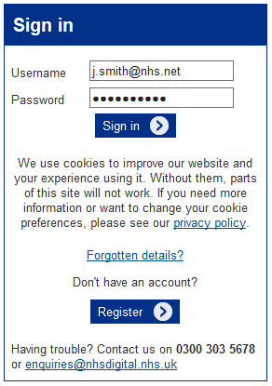

Step 4: Complete the Patient Information
Complete the patient record by entering the First name and Surname of the patient and select the patient’s gender and ethnicity from the drop down lists.

To enter GP Practice Code, select the field and search for the correct GP practice by either GP Practice Code or Name. Please note that the search is case sensitive so use UPPER CASE text when searching. Click on the correct GP Practice in the search results to make your selection. Click on ‘Submit’ to save the record.


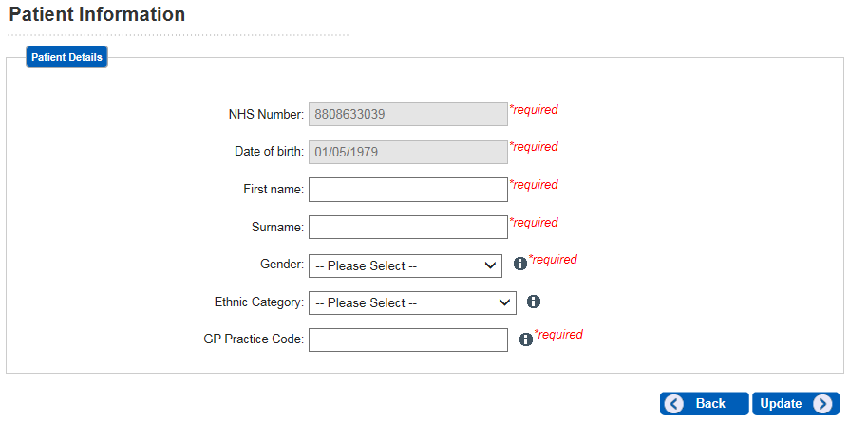

Step 2: Access the Out of Area Placements Collection
Once you are signed in click on ‘Out of Area Placements’ under ‘My Available Audits’.
The OAP Home screen will be
displayed.

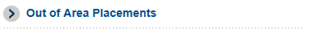

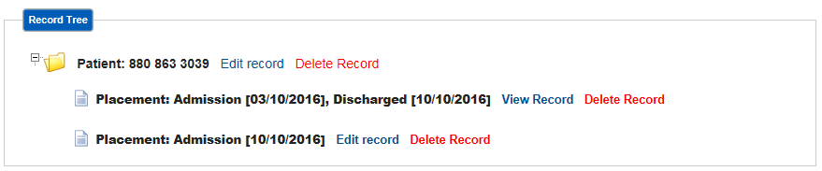

Step 5: Add Placement Record
Once the patient record has been entered, the Record Tree will be displayed.

Click on ‘Add Placement’ to create a new placement record. The ‘Placement’ screen is displayed.

Complete all fields within the placement record and click on ‘Submit’.
Where the ‘Out of Area Placement Discharge Date’ is unknown, please enter a dummy date of 01/01/1900. You will need to amend the record with the correct information, once known at a later date.
Once a valid date is entered into this field, and the data is updated, the record will become read only and no further changes to that placement record may be made.

Step 6: Editing an Existing Record
To edit an existing record, click on ‘Add/Search for Patient Record’ at the top of the screen. Enter the patient’s NHS Number and date of birth. If a record already exists for that patient, the patient’s record tree will be displayed. From here, you are able to view, edit or delete both the patient and placement records.

The top level ‘Patient’ folder displays the patient’s NHS Number. Click on Edit Record to access the patient information and amend the fields.
Please note that once a patient is created, their NHS number cannot be amended. If entered in error click on Delete Record to delete the entire patient record and all associated placements, and then add the record again
The ‘Placement’ records sit below the Patient folder. Each patient may have multiple placement records.
For ‘open’ placement records (i.e. records which do not have a valid discharge date), only the admission date is displayed against each record. Click on Edit Record to access the placement information and amend any of the fields. Click on Delete Record to remove the placement record from the database.
For ‘closed’ placement records (i.e. records which do have a valid discharge date) both the admission date and discharge date are displayed against each record. Click on View Record to access the placement information and view what data has been submitted. Click Delete Record to remove the placement record from the database. Note: Closed placement records cannot be edited.

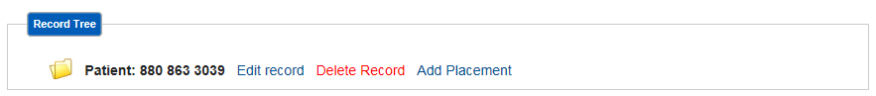

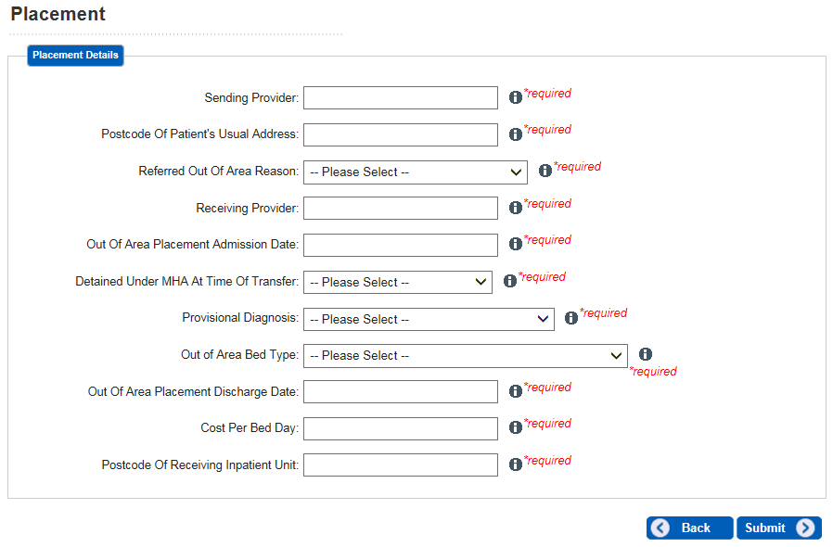

Further Information
For further information please visit the OAPs website or contact the NHS Digital Contact Centre on 0300 303 5678 or email enquiries@nhsdigital.nhs.uk (please enter ‘OAPs Collection’ in the subject field of your email).

