Query | Answer | Location of guidance
ACCESSING NWRS
Who do I contact to add my Assistant PM? | The Practice manager should contact the National Service Desk:  Contact Email - ssd.nationalservicedesk@nhs.net  Please include the Practice Name or PCN Name, The ODS Code, The persons full name and the NHS email address (shared email addresses are not allowed) –  Please see guidance here: | https://digital.nhs.uk/data-and-information/areas-of-interest/workforce/national-workforce-reporting-service-nwrs/guidance/access-to-nwrs-and-registering
How do I know if I have access to be able to input information? | Please login to SDCS and following the login steps (if you can check now) we can try to get it sorted if it does not work  NWRS can be accessed (and you can request an account) here: | https://digital.nhs.uk/data-and-information/areas-of-interest/workforce/national-workforce-reporting-service-nwrs/guidance/access-to-nwrs-and-registering
I am Finance Manager at a GP Practice and have been asked to input this information in future. How do I know if I already have access or, if not, how do I get access | NWRS can be accessed (and you can request an account) here: | https://digital.nhs.uk/data-and-information/areas-of-interest/workforce/national-workforce-reporting-service-nwrs/guidance/access-to-nwrs-and-registering
I haven't been able to set up an account to update the NWRS myself. I presume I just need to email ssd.nationalservicedesk. | Yes, please get in touch - accounts are set up and verified by the National Service Desk.  Your Practice Manager will need to contact the NSD:  Contact Email - ssd.nationalservicedesk@nhs.net  Please include the Practice Name or PCN Name, The ODS Code, The persons full name and the NHS email address (shared email addresses are not allowed). | https://digital.nhs.uk/data-and-information/areas-of-interest/workforce/national-workforce-reporting-service-nwrs/guidance/access-to-nwrs-and-registering
STAFF TO INCLUDE IN NWRS
Do we add GP registrars if we are a training practice? | No, registrars/junior doctors/foundation doctors and medical students should not be recorded in NWRS as this information is already captured on the Trainee Information System (TIS) | https://digital.nhs.uk/data-and-information/areas-of-interest/workforce/national-workforce-reporting-service-nwrs/guidance/providing-staff-information#staff-to-include-in-nwrs
USING THE NWRS
RESPONSIBILITIES
Also, what happens if we do not log in once a month? It can be hard to remember if you have had no staff changes. | It is a monthly requirement to login - it is published on the NWRS DQ Dashboard so Workforce Planners, ICBs etc. can monitor compliance; we try to make it as easy as possible so if you have no changes, you can go to the staff details pages, double check all is up to date, and then log out. | https://digital.nhs.uk/data-and-information/areas-of-interest/workforce/national-workforce-reporting-service-nwrs/guidance/responsibilities#requirement-to-submit-monthly-staff-information
Could a Practice or PCN be found in breach of their Contract if they do not complete NWRS submissions? | Technically, yes. Provision of accurate staff information is critical for workforce planning and funding and is a contractual require. You don't need to provide information on NWRS regularly (it's not a submission per se), only if anything changes so your records are up to date, so once the information is in in the system, the burden is minimal and you only need to log in once per month to check your records are up to date. Compliance is monitored by NHS England centrally, as well as Regional and ICB Leads, etc. | https://digital.nhs.uk/data-and-information/areas-of-interest/workforce/national-workforce-reporting-service-nwrs/guidance/responsibilities#requirement-to-submit-monthly-staff-information
Do we have to get permission from Locums to be entering this data, especially NI numbers (as they are self-employed)? | You have a duty to inform them, but it is a contractual requirement for the organisation to provide NWRS information. NI is not mandatory, although very useful to us for generating accurate Official Statistics | https://digital.nhs.uk/data-and-information/areas-of-interest/workforce/national-workforce-reporting-service-nwrs/guidance/responsibilities#requirement-for-staff-consent-to-upload-their-personal-information
Why do you need the NI number for PCN staff? | We require NI numbers for all staff not just PCN staff. it is a unique identifier to look at staff working at more than one practice or PCN and the following link gives you more information: | The legal bases for the collection: https://digital.nhs.uk/data-and-information/areas-of-interest/workforce/national-workforce-reporting-service-nwrs/how-we-use-the-workforce-data-you-provide  The GDPR Notice : https://digital.nhs.uk/data-and-information/keeping-data-safe-and-benefitting-the-public/gdpr/gdpr-register/general-practice-workforce-minimum-dataset-gp-wmds
In the PCN area - you don’t really want staff details that are employed which are not attracting ARRS funding surely? As a Federation, we do not list our staff details who support the PCNs, as they are not ARRS funded - or do you mean we do need to enter those details now. I was assuming your slide was relevant to practice teams, not federations? | All staff working at the practice and at the PCN should be recorded. Any receiving funding through the PCN should be recorded by the PCN rather than the practice (you’ll need to liaise with the PCN to provide this information for them to enter, unless you are also an administrator with access to the PCN on NWRS). All other staff undertaking PCN work should be recorded according to their funding; if it’s a split role (i.e., partially funded by the PCN) then there should be an entry in both the PCN and the practice module reflecting the contracted hours at each organisation.  Please contact us to discuss if you need more tailored guidance based on your circumstances. | Please see guidance:  https://digital.nhs.uk/data-and-information/areas-of-interest/workforce/national-workforce-reporting-service-nwrs/guidance/providing-staff-information#when-to-use-pcn-and-gp-practice-modules  https://digital.nhs.uk/data-and-information/areas-of-interest/workforce/national-workforce-reporting-service-nwrs/guidance/providing-staff-information#recording-pcn-staff  https://digital.nhs.uk/data-and-information/areas-of-interest/workforce/national-workforce-reporting-service-nwrs/guidance/providing-staff-information#how-to-record-staff-working-at-both-a-gp-practice-and-the-pcn
USING NWRS TO VIEW DATA
Each time you make a submission you are shown a submission reference number - are these viewable anywhere on NWRS? | the submission ID is available when you click "View" against the record | 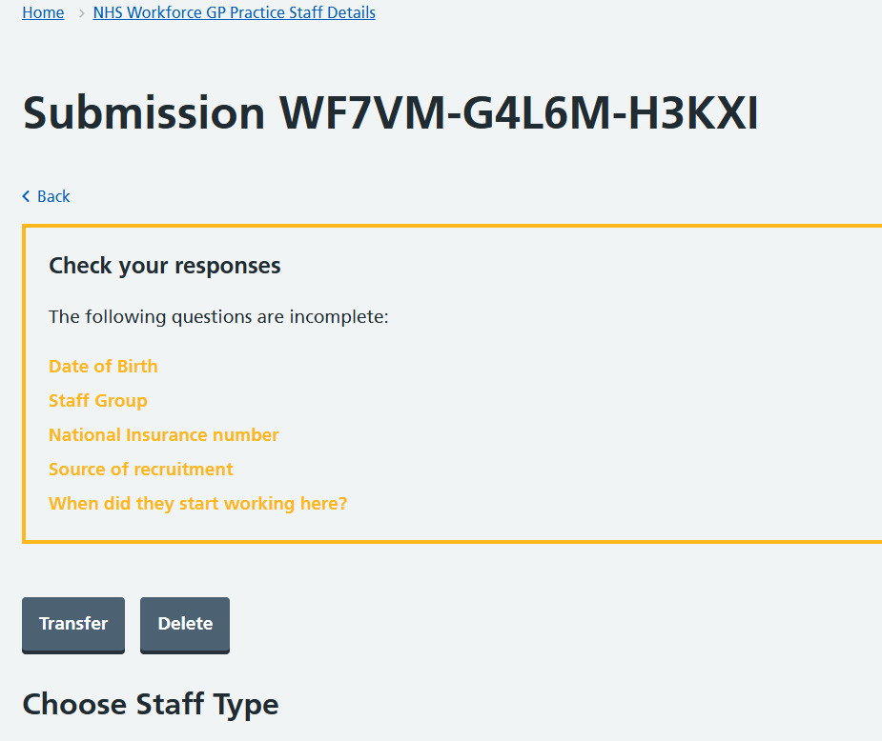
USING THE DATA QUALITY DASHBOARD TO VIEW DATA
Which website address can the NWRS dashboard be found at? | Please see here: | https://digital.nhs.uk/data-and-information/areas-of-interest/workforce/national-workforce-reporting-service-nwrs#nwrs-dashboard
Sorry if I missed it - where can you see the number of in progress records in the DQ dashboard? | The counts for in progress records are included in the downloadable .csv files published every week alongside the dashboard, but are not currently visible on the dashboard. This development will be added later this year. In progress counts can also be seen in the staff table when you log into NWRS. | https://digital.nhs.uk/data-and-information/areas-of-interest/workforce/national-workforce-reporting-service-nwrs#nwrs-dashboard
PROVIDING STAFF INFORMATION
What if someone goes on maternity leave?  If staff member goes on maternity leave, do we enter as 'pregnancy' with leaving date and add new date and hours on their return to work | We are working on some developments to record specific types of long-term leave, but for now, please record the actual hours worked field as zero (with the contracted hours filled out with their normal hours) until they return to work.  No, the member of staff should remain on NWRS. | https://digital.nhs.uk/data-and-information/areas-of-interest/workforce/national-workforce-reporting-service-nwrs/guidance/providing-staff-information#how-to-record-hours-worked-by-each-person
If someone leaves and then comes back 2 year later, do we amend the old record or create a new one? | Yes, you would create a new record for the individual. | https://digital.nhs.uk/data-and-information/areas-of-interest/workforce/national-workforce-reporting-service-nwrs/support#how-to-videos
Hi, how is best to record overtime hours. We pay our overdue in arrears, how would I record this on a staff members record? | Please see guidance here: | https://digital.nhs.uk/data-and-information/areas-of-interest/workforce/national-workforce-reporting-service-nwrs/guidance/providing-staff-information#how-to-record-hours-worked-by-each-person
If you have a GP on a temporary contract but then they move to a different contract, do you mark as a leaver then starter | Provided the member of staff remains in the same staff group (so the same validations apply), the record can be updated with the new contract type. | https://digital.nhs.uk/data-and-information/areas-of-interest/workforce/national-workforce-reporting-service-nwrs/guidance/providing-staff-information#how-to-record-that-a-person-s-role-has-changed
If PCN claims ARRS funding for Pharmacist that are paid by their employer then invoice the PCN, does this need to be documented on the PCN work force? | Yes, if any funding comes through the PCN, these staff should be recorded in the PCN module. The funding details themselves are not data required in NWRS. | https://digital.nhs.uk/data-and-information/areas-of-interest/workforce/national-workforce-reporting-service-nwrs/guidance/providing-staff-information#recording-pcn-staff  https://digital.nhs.uk/data-and-information/areas-of-interest/workforce/national-workforce-reporting-service-nwrs/guidance/providing-staff-information#recording-additional-roles-reimbursement-scheme-arrs-in-nwrs
This information has changed, previously we were told that for practice employed ARRS roles, that the practices had to make the entries on their NWRS entries, please can you tell us why this has changed, as it has never been shared with us , that it has changed, thanks | This information changed a couple of years back, and we communicated this at the time to all registered NWRS users via the monthly comms, and also via our website. The information is still in our comms as a reminder. The practice should liaise with the PCN to give them the information required. | https://digital.nhs.uk/data-and-information/areas-of-interest/workforce/national-workforce-reporting-service-nwrs/guidance/providing-staff-information#recording-gp-practice-staff-that-now-work-at-pcn-level
I think the previous guidance was aligned to the EMPLOYER of the role being the responsible person to put the information on NWRS. | Since the introduction of ARRS roles, the guidance has been around the funding of the roles. | https://digital.nhs.uk/data-and-information/areas-of-interest/workforce/national-workforce-reporting-service-nwrs/guidance/providing-staff-information#when-to-use-pcn-and-gp-practice-modules
Please can you clarify whether a practice should be recording ARRS staff employed by the PCN or secondary care and locums? | Any staff funded through or by the PCN (including ARRS staff and locums) should be recorded by the PCN. | please see guidance here: https://digital.nhs.uk/data-and-information/areas-of-interest/workforce/national-workforce-reporting-service-nwrs/guidance/providing-staff-information#roles-paid-directly-by-or-through-the-pcn
Can I please confirm, a third party employed member of ARRS staff (MHP employed by LPFT but working for the PCN) if they are a named person, should they be named in staff section rather than contracted services? | If the PCN is receiving ARRS funding for this role you would put them under the staff details.  If it is a service you have bought in (contract from the Foundation Trust) and it is the same person filling the role for the duration of the service then it will be Staff Details  If the service is not funded and is filled by multiple different people, then you should use the Contracted Services module. | https://digital.nhs.uk/data-and-information/areas-of-interest/workforce/national-workforce-reporting-service-nwrs/guidance/providing-staff-information#recording-agency-staff-used-by-the-pcn  https://digital.nhs.uk/data-and-information/areas-of-interest/workforce/national-workforce-reporting-service-nwrs/guidance/providing-staff-information#recording-roles-that-are-partly-funded-by-a-non-primary-care-source
For PCNs that have paid 'lead roles' on an ad hoc or sessional basis, would you class them as PCN workforce and include them? | Yes, these should be recorded against the PCN - you can select the appropriate contract type. | https://digital.nhs.uk/data-and-information/areas-of-interest/workforce/national-workforce-reporting-service-nwrs/guidance/providing-staff-information#recording-pcn-staff
If a GP is temp staff and then made permanent on ARRS but does some hours as practice staff do they need entries on both? | Yes, you need to have a record for the ARRS funding in the PCN module and a record for the GP services they provide in the GP Practice. | https://digital.nhs.uk/data-and-information/areas-of-interest/workforce/national-workforce-reporting-service-nwrs/guidance/providing-staff-information#how-to-record-staff-working-at-both-a-gp-practice-and-the-pcn
For staff that the practices employ (funded through ARRS) do you suggest that they end their contract, state transfer to PCN as the reason, and the PCN NWRS record then starts with their contract as a new date of 1st April 2025, or state that it is their original contracted start date? This is so we can get their records accurately recorded in the PCN module now. | Please liaise with the PCN to provide the information so they can set up the records in the PCN module - with the original joining date. Once they're happy with the completed records, you can delete your copy of the records, stating reason for deletion as "created in error" (which is the most appropriate option we have).  If it would be helpful, you can arrange a support call with our team by emailing the National Service Desk and quoting “NWRS support call request” in the subject line. | https://digital.nhs.uk/data-and-information/areas-of-interest/workforce/national-workforce-reporting-service-nwrs/guidance/providing-staff-information#recording-gp-practice-staff-that-now-work-at-pcn-level  https://digital.nhs.uk/data-and-information/areas-of-interest/workforce/national-workforce-reporting-service-nwrs#contact-us
I work for a Training Hub and we also support workforce development. How and what can I access in terms of data please? | Only GP practice and PCN staff can access the NWRS system. However, you can access our regular published statistics, user statistics, and data quality dashboard information.  You can access the CSV files for the DQ Dashboard, the user stats for the practices and PCNs using NWRS - | Data quality dashboard and downloads (includes user statistics): https://digital.nhs.uk/data-and-information/areas-of-interest/workforce/national-workforce-reporting-service-nwrs#nwrs-dashboard  GP Publication - https://digital.nhs.uk/data-and-information/publications/statistical/general-and-personal-medical-services  PCN Publication - https://digital.nhs.uk/data-and-information/publications/statistical/primary-care-network-workforce
How do we support practices to keep their data up to date when they ask 'what's in it for me?' | Decisions around funding and planning (as demonstrated in the Case Study session for example) are often made on the data that comes out of NWRS. We also occasionally field questions (such as Freedom of Information requests) about staffing levels in particular settings and we'd never want to be making decisions or answering these questions - that may affect the practice - on out of date or inaccurate data. | N/A
Can we be added to the monthly newsletter distribution list please even if we're not NWRS users? | We'll add you to our stakeholder list for a copy of the monthly comms. Any other stakeholders who wish to be added to this list for copies of our monthly extraction reminder (know as the “monthly comms” as it includes updates) can request this by emailing ssd.nationalservicedesk@nhs.net and quoting “FAO NWRS team – request to be added to monthly comms mailing list”. | https://digital.nhs.uk/data-and-information/areas-of-interest/workforce/national-workforce-reporting-service-nwrs/guidance/access-to-nwrs-and-registering#nwrs-accounts-for-stakeholders-and-regional-leads
Will be moved to using our smartcard rather than login | This is not currently planned as this system isn't linked - future developments (depending on the future location of NHS systems following integration into DHSC) may include this. | N/A
The non-clinical workforce needs to be better represented in these reports please - and indeed Practice Managers | Thanks for your feedback – the publications team have taken note. | N/A
will we receive copies of the slides? | You can download a copy of the slides here: | https://digital.nhs.uk/data-and-information/areas-of-interest/workforce/national-workforce-reporting-service-nwrs#webinars

Useful links
Contact Email - ssd.nationalservicedesk@nhs.net
SDCS Collection Page - https://datacollection.sdcs.digital.nhs.uk/
NWRS DQ Dashboard - https://digital.nhs.uk/data-and-information/areas-of-interest/workforce/national-workforce-reporting-service-nwrs#nwrs-dashboard
NWRS Support Page - https://digital.nhs.uk/data-and-information/areas-of-interest/workforce/national-workforce-reporting-service-nwrs/support
NWRS How to Videos - https://digital.nhs.uk/data-and-information/areas-of-interest/workforce/national-workforce-reporting-service-nwrs/support#how-to-videos
NWRS Guidance and Support - https://digital.nhs.uk/data-and-information/areas-of-interest/workforce/national-workforce-reporting-service-nwrs/guidance
NWRS How we use your data - https://digital.nhs.uk/data-and-information/areas-of-interest/workforce/national-workforce-reporting-service-nwrs/how-we-use-the-workforce-data-you-provide
ODS (Searching Organisation Code) - https://odsportal.digital.nhs.uk/Organisation/Search
GP Publication - https://digital.nhs.uk/data-and-information/publications/statistical/general-and-personal-medical-services
PCN Publication - https://digital.nhs.uk/data-and-information/publications/statistical/primary-care-network-workforce

