
NHS England
Quarry House
Leeds LS2 7UE

Simon Bolton
Interim Chief Executive
NHS Digital
7 & 8 Wellington Place
Leeds
West Yorkshire
LS1 4AP

13th December 2021

Dear Simon,

Online and Video Consultation Directions 2021
  - I am writing on behalf of the National Health Service Commissioning Board (known as NHS England) to provide Directions to the Health and Social Care Information Centre, known as and hereafter referred to in these Directions as NHS Digital.
  - These Directions are given in exercise of the powers conferred by sections 254(1), (3) and (6), section 260(2)(d), section 261(2)(e) and section 304(9), (10) and (12) of the Health and Social Care Act 2012 (the 2012 Act).
  - In exercising the activities and functions described in these Directions, NHS Digital must have regard to such priorities, policies, advice or guidance of NHS England as NHS England may notify in writing from time to time to NHS Digital.
  - These Directions are to be known as the Online and Video Consultation Directions 2021 and come into force on the date signed.

Purpose
  - The purpose of these Directions (Purpose) is to formalise the standard data collection of information related to online consultations and video consultations systems and their use in general practice, beyond the national COVID-19 response. The data collection will provide vital information both to general practices and local commissioners on the amount of activity taking place via these channels and systems, which will further understanding of demand and activity in general practice and therefore help to guide implementation planning, support and resources. The use of online and video consultation systems in general practice are part of the NHS Long Term Plan and were an integral part of primary care’s response to COVID-19. This data collection and the data it contains may be used to incentivise and reward practices.
  - Online and Video consultation supplier incident data will be collected to spot trends and develop best practice for suppliers in responding to these incidents. Due to the commercial nature of this data, the incident data listed in the data collection will be prohibited from being published.

Establishing and operating information systems for the Online and Video Consultation Directions data collection
  - In accordance with sections 254(1) and 254(6) of the 2012 Act, NHS England directs NHS Digital to establish and operate a system for the collection and analysis of information described in the Online and Video Consultation (undertaken in GP Practice) Directions Requirements Specification issued as Annex A of these Directions, as the same may be updated in accordance with paragraph 3.4 below (Requirements Specification), such system to be known as the Online and Video Consultation Directions Information System.
  - Pursuant to NHS England’s powers under 254(1) and 254(6) of the 2012 Act, NHS Digital is directed to analyse the information collected pursuant to and/or obtained by NHS Digital complying with these Directions, as may be requested by NHS England or as NHS Digital determines is necessary to achieve the Purpose.
  - Such analysis referred to above includes:
    - analysis by reference or linkage to other data as described in the Requirements Specification;
    - analysis for data quality purposes, including undertaking comparison and consistency analysis of the same or similar information obtained through other information systems established by NHS Digital under any other direction under section 254 of the 2012 Act, and taking such steps as NHS Digital considers appropriate to maintain data quality, accuracy and consistency of information it has obtained under these Directions and across all information systems.
  - NHS Digital is directed to carry out the activities above in accordance with the Requirements Specification and in such a way as to enable and facilitate the Purpose described above. The Requirements Specification may be updated periodically (within the confines of the scope set out in these Directions) by NHS Digital on agreement in writing by NHS England.

Requirement for these Directions
  - In accordance with section 254(3) of the 2012 Act, NHS England considers that the information which could be obtained by complying with these Directions is information which it is necessary or expedient for NHS England to have in relation to its exercise of functions in connection with the provision of NHS services.
  - In accordance with section 254(5) of the 2012 Act, NHS Digital has been consulted before these Directions have been given.

Publication
In accordance with section 260(2)(d) of the 2012 Act, NHS Digital is directed not to publish information that is specified as not for publication in the Requirements Specification. Any other information must be published in line with NHS Digital’s duty under section 260(1) of the 2012 Act unless it falls within section 260(2) of the 2012 Act.

Dissemination
  - Pursuant to section 261(2)(e) of the 2012 Act, NHS Digital may disseminate under section 261(1) of the 2012 Act the information it has obtained by complying with these Directions, including to NHS England and other parties identified by NHS England that have a lawful basis to receive the information (in consultation with NHS Digital), where section 261(1) would otherwise not apply due to the restriction on publication above, and where it would be lawful for NHS Digital to do so.
  - Pursuant to section 262(3) of the 2012 Act, NHS Digital is directed to exercise its powers under section 261(4) of the 2012 Act to disseminate the information collected pursuant to these Directions to the organisations that provided the information where it would be lawful for NHS Digital to do so.
  - Information collected as a result of, or obtained by complying with, these Directions may also be disseminated in accordance with NHS Digital’s powers under sections 261(4) and (5) of the 2012 Act.

Fees and Accounts
  - Pursuant to section 254(7) of the 2012 Act, NHS Digital is entitled to charge NHS England a reasonable fee in respect of the cost of NHS Digital complying with these Directions.
  - NHS Digital must keep proper accounts, and proper records in relation to the accounts, in connection with the Online and Video Consultation Directions 2021.

Duration
NHS Digital is directed to operate the Online and Video Consultation Directions Information System (the Directed Function) unless and until revoked by a further direction or instructed in writing by an authorised officer of NHS England on reasonable notice to suspend and/or permanently cease the Directed Function. Where the Directed Function is to cease, such written request will also contain a direction to revoke these Directions in accordance with the timescales and arrangements to be agreed with NHS Digital.

Review of these Directions
These Directions will be reviewed when the Requirements Specification is amended. This review will include consultation with NHS Digital.

Yours sincerely
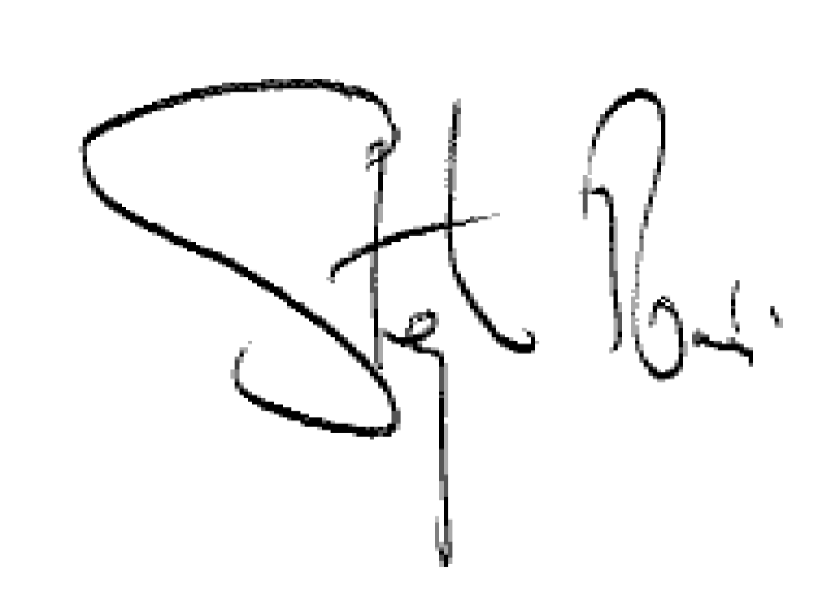
Signed by authority of NHS England

ANNEXES - the Online and Video Consultation Directions 2021

Annex A - Online and Video Consultation (undertaken in GP Practice) Directions Requirements Specification

2012 c.7

